Discover Vietnam with INTRO TRAVELS INDIA
Vietnam is one of Southeast Asia’s most exciting travel destinations, famous for its breathtaking landscapes, emerald bays, ancient towns, vibrant cities, delicious street food, rich history, and affordable luxury experiences. From the limestone islands of Ha Long Bay to the lantern-lit streets of Hoi An, Vietnam offers the perfect blend of culture, adventure, relaxation, and natural beauty.
Whether you are planning a honeymoon, family holiday, solo trip, or group tour, Vietnam promises an unforgettable travel experience.

Why Visit Vietnam?
- Stunning natural landscapes & beaches
- Affordable international destination
- Rich culture & ancient heritage
- World-famous street food
- Scenic cruises & mountain adventures
- Vibrant cities & nightlife
- Friendly locals & unique traditions
- Great value luxury travel

Top Tourist Attractions in Vietnam
1. Hanoi – The Cultural Capital
Vietnam’s capital city is famous for old-world charm, street food, and historic attractions.
Top attractions:
- Hoan Kiem Lake
- Old Quarter
- Ho Chi Minh Mausoleum
- Temple of Literature
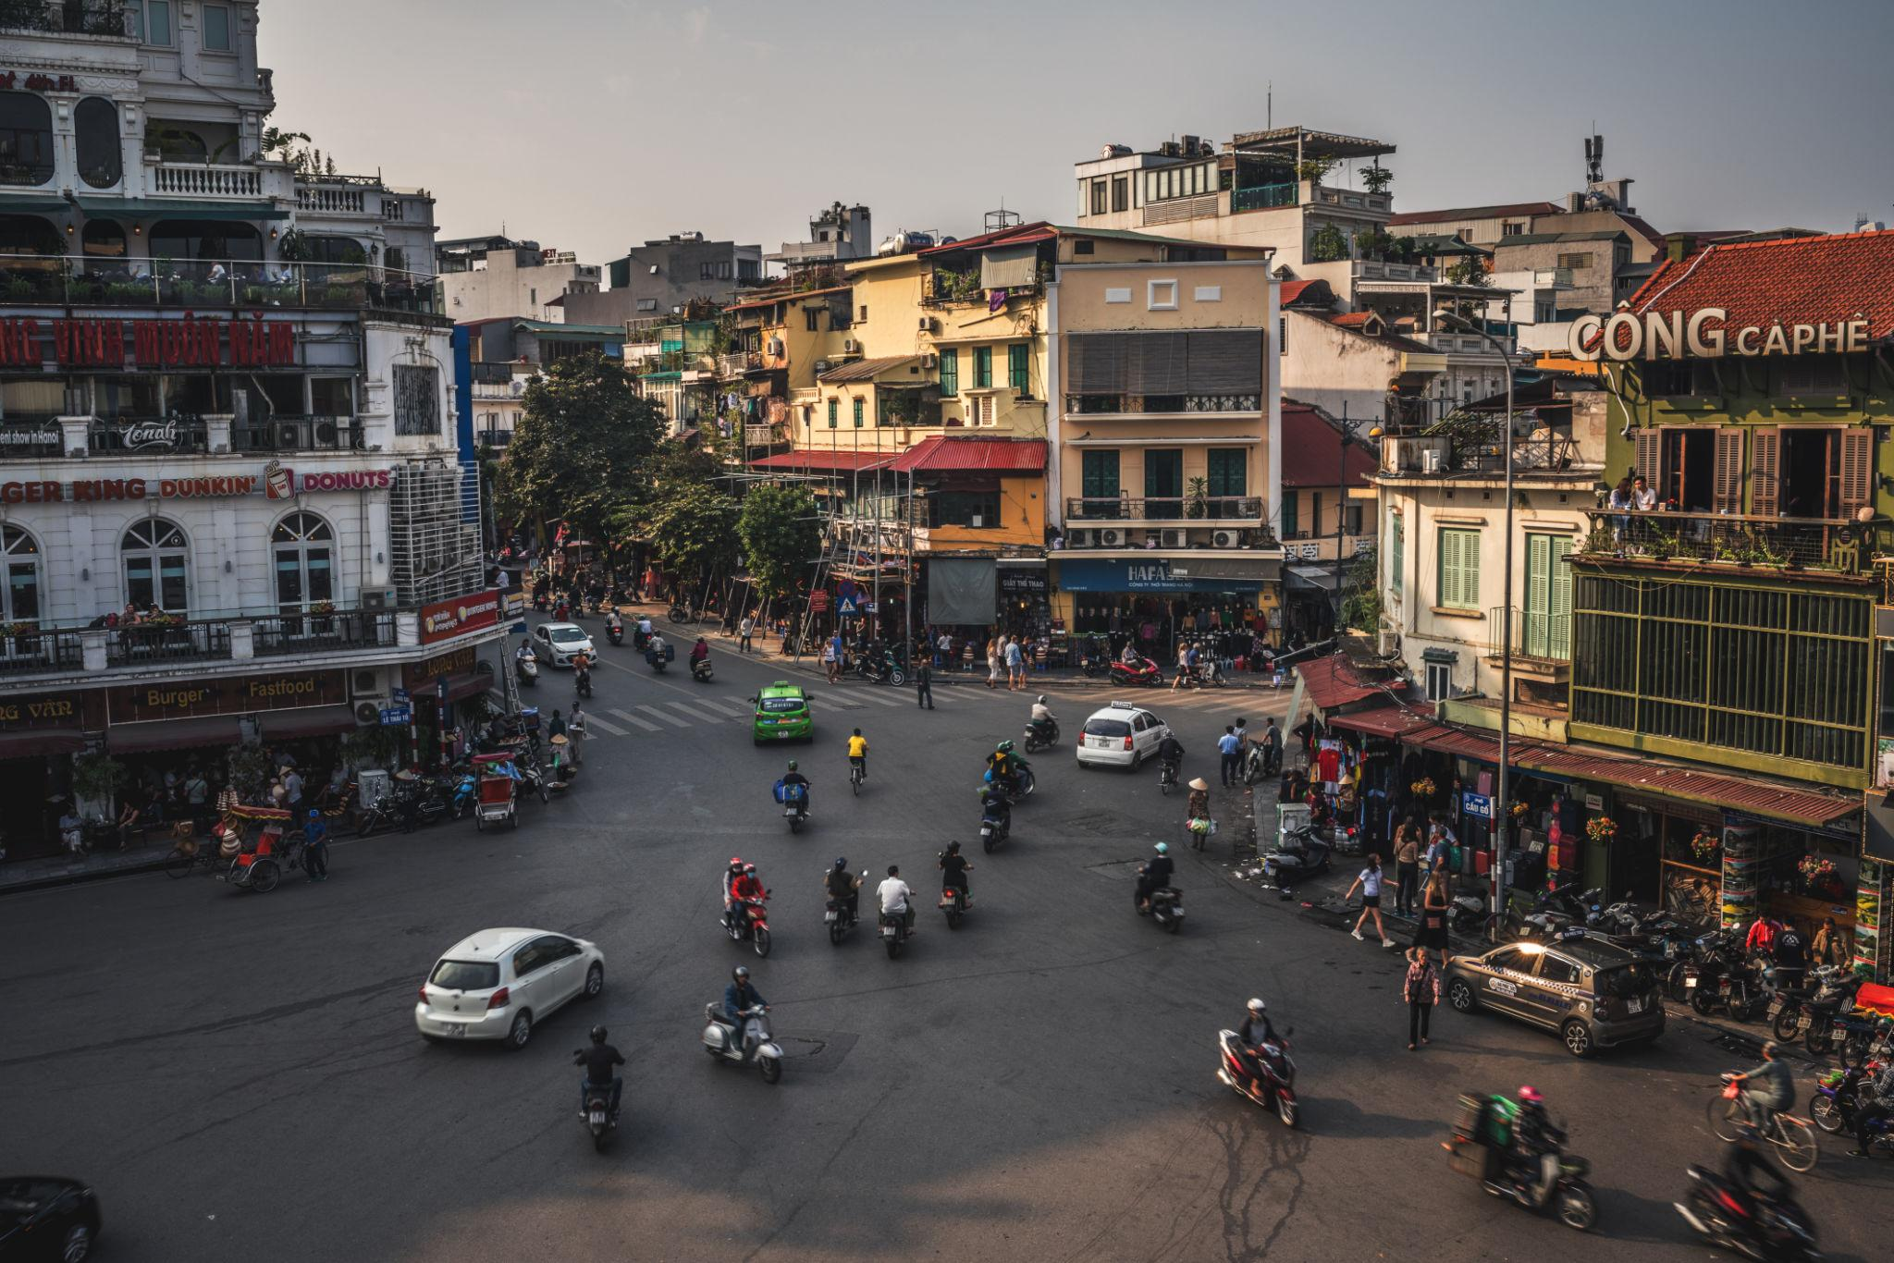
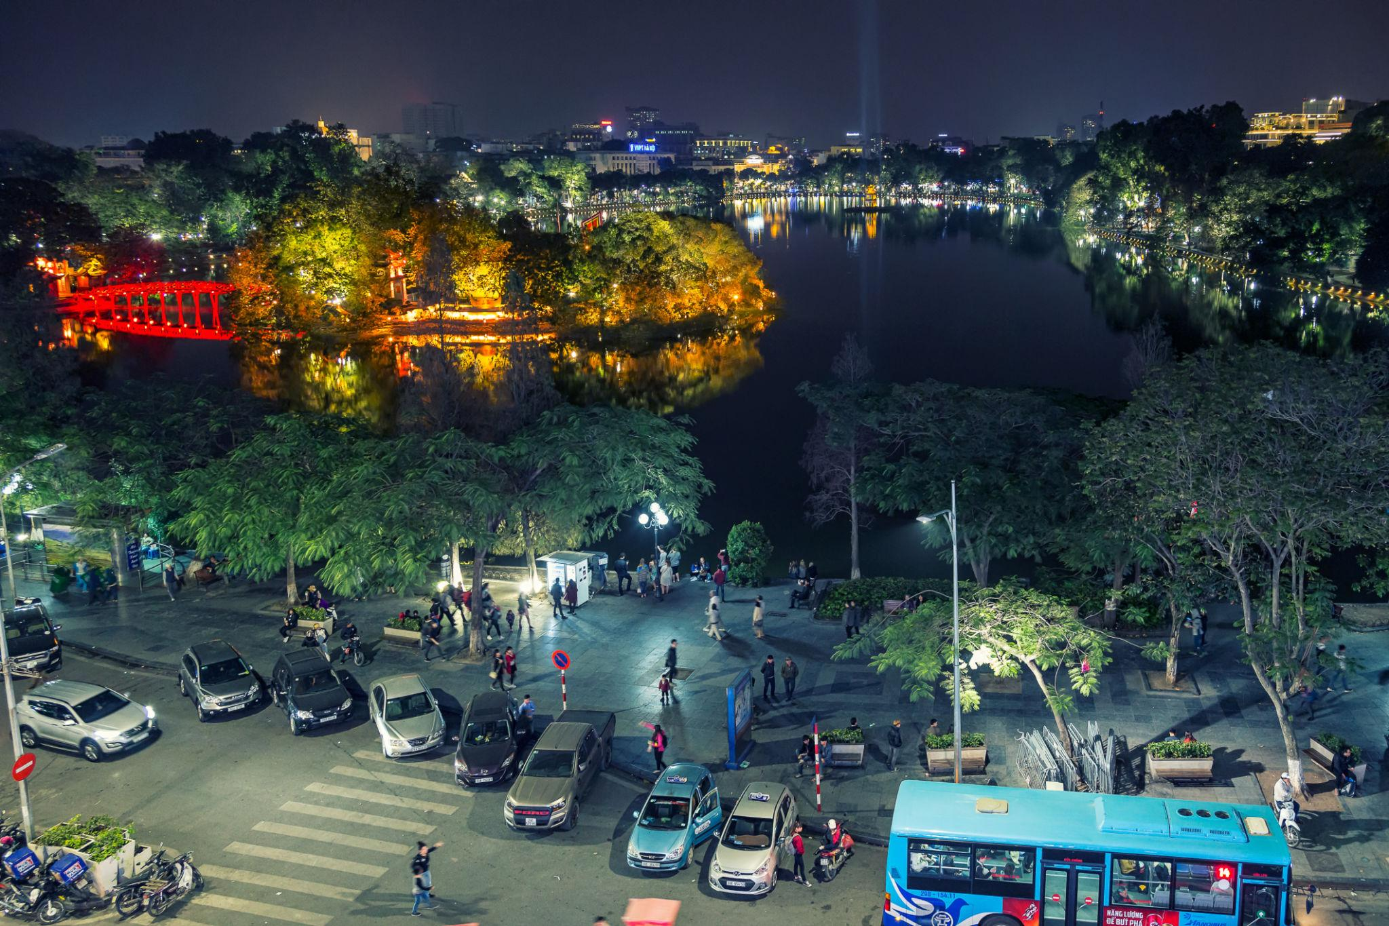
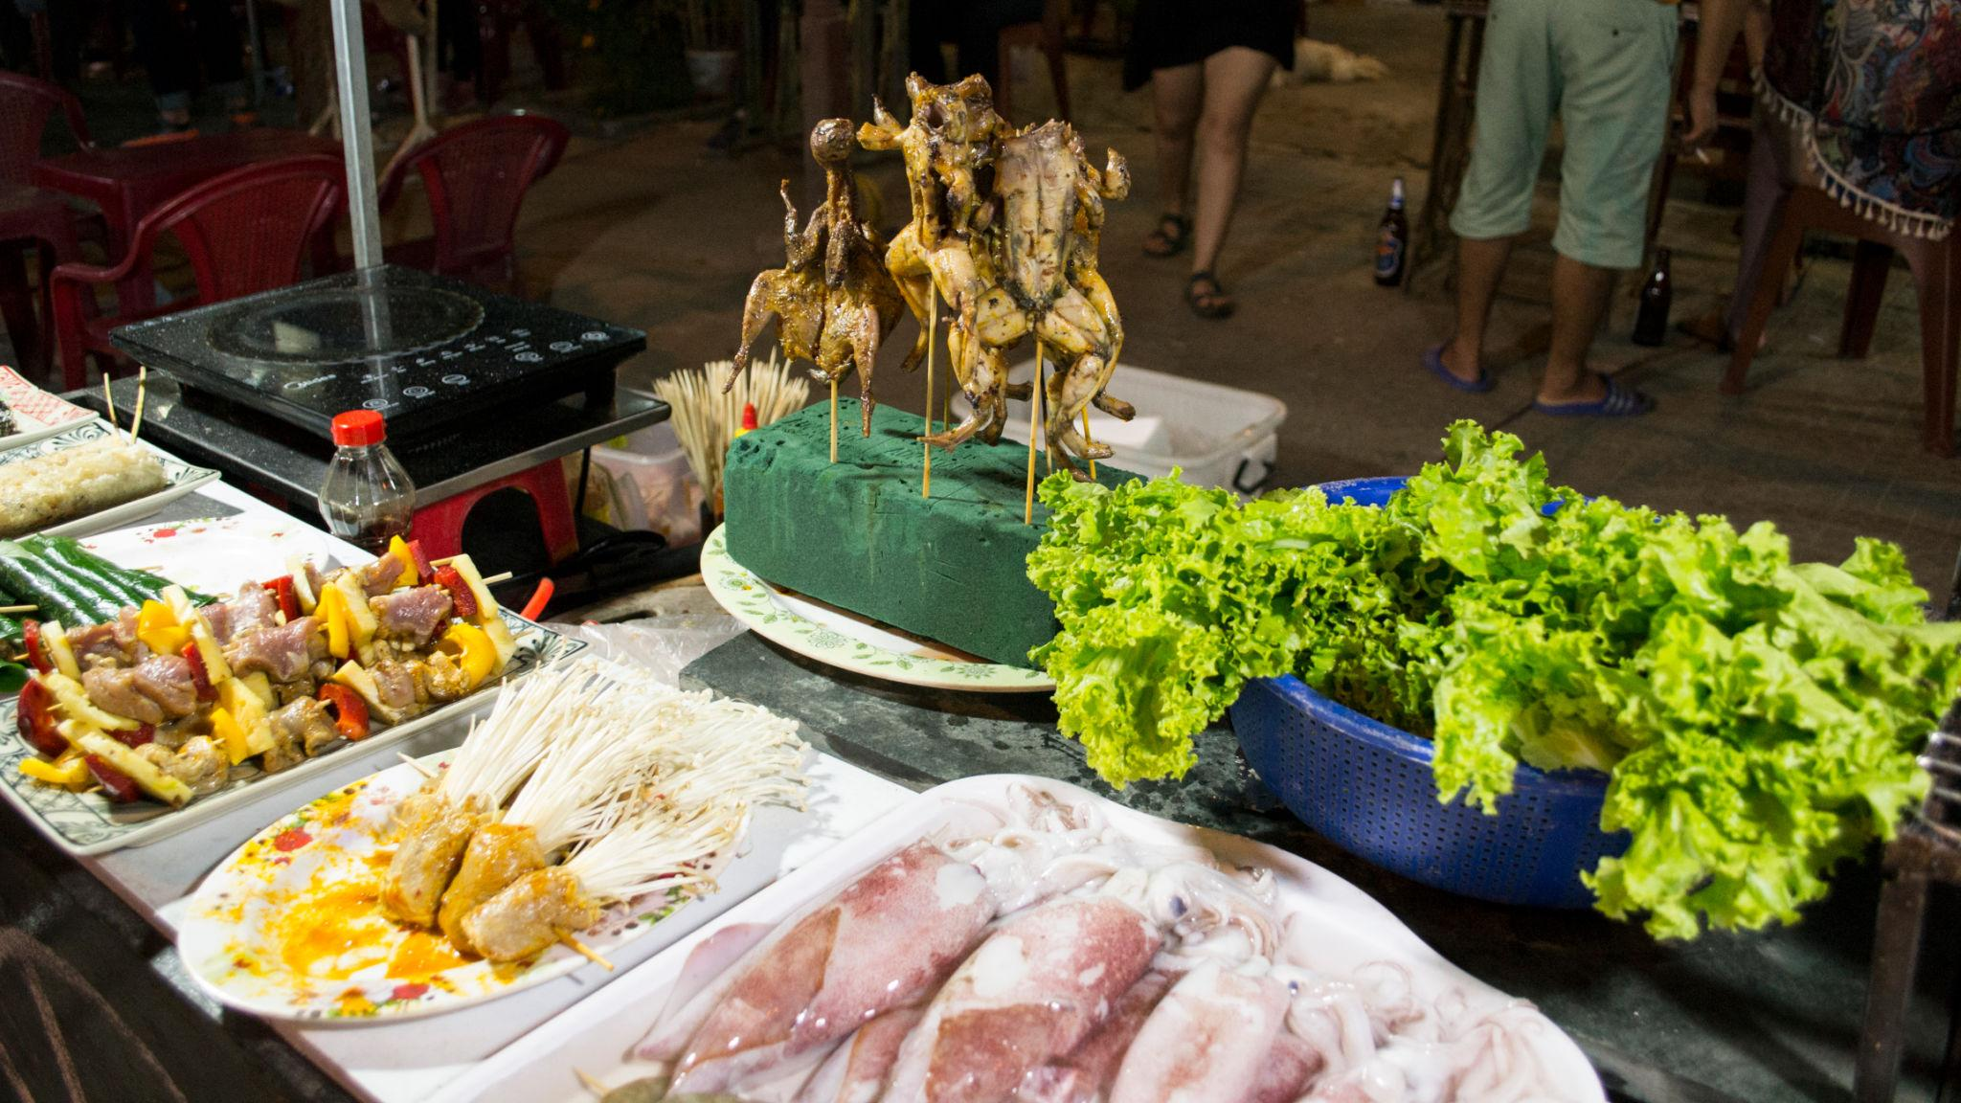
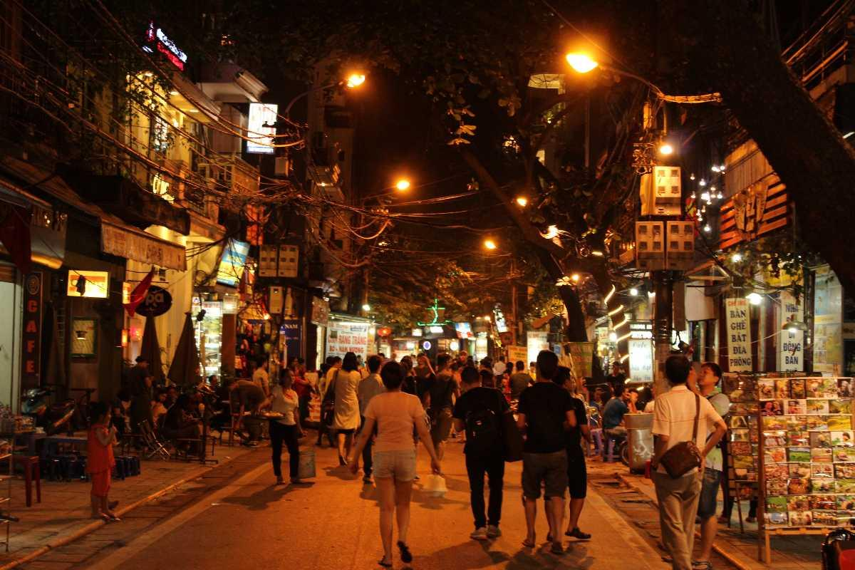
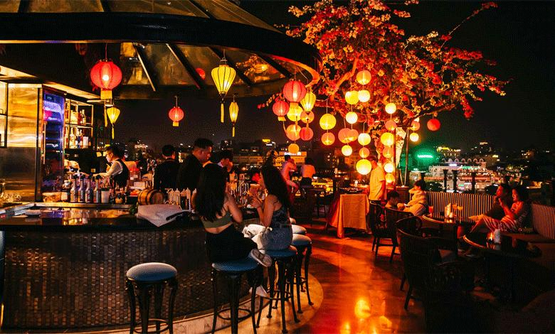
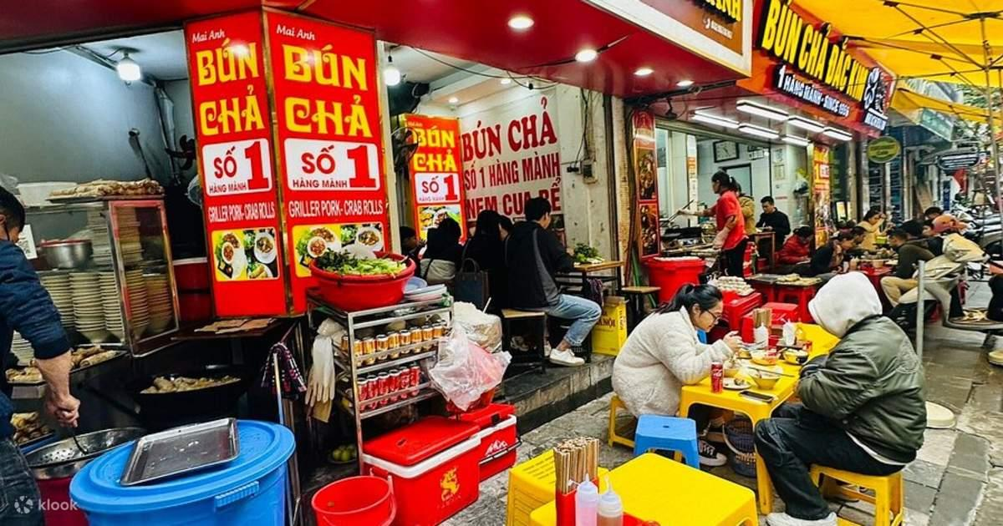
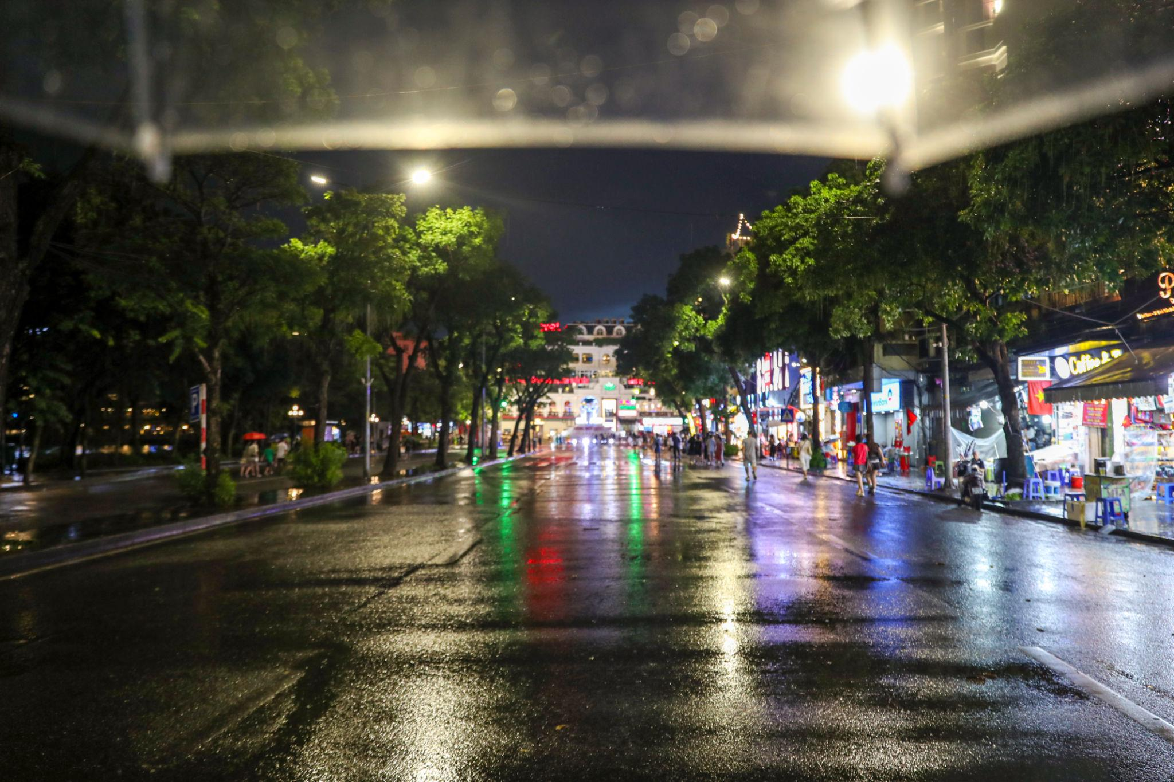

2. Ha Long Bay
A UNESCO World Heritage Site famous for emerald waters and limestone islands.
Best experiences:
- Luxury overnight cruises
- Kayaking
- Cave exploration
- Sunset dining on cruises
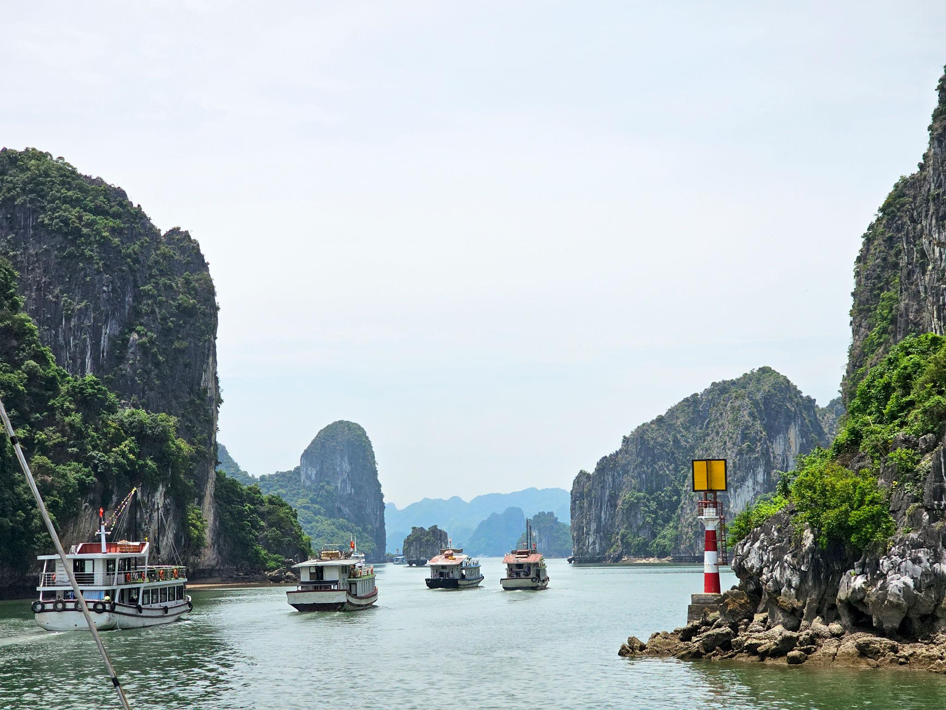
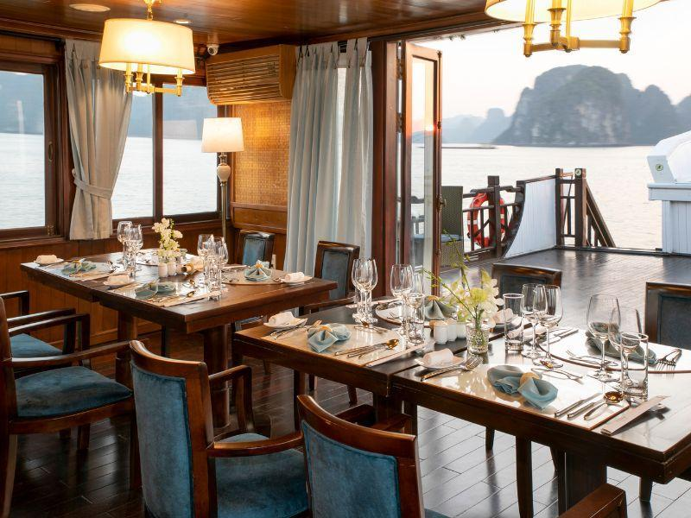
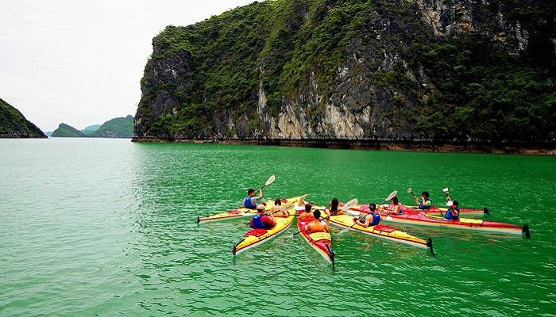
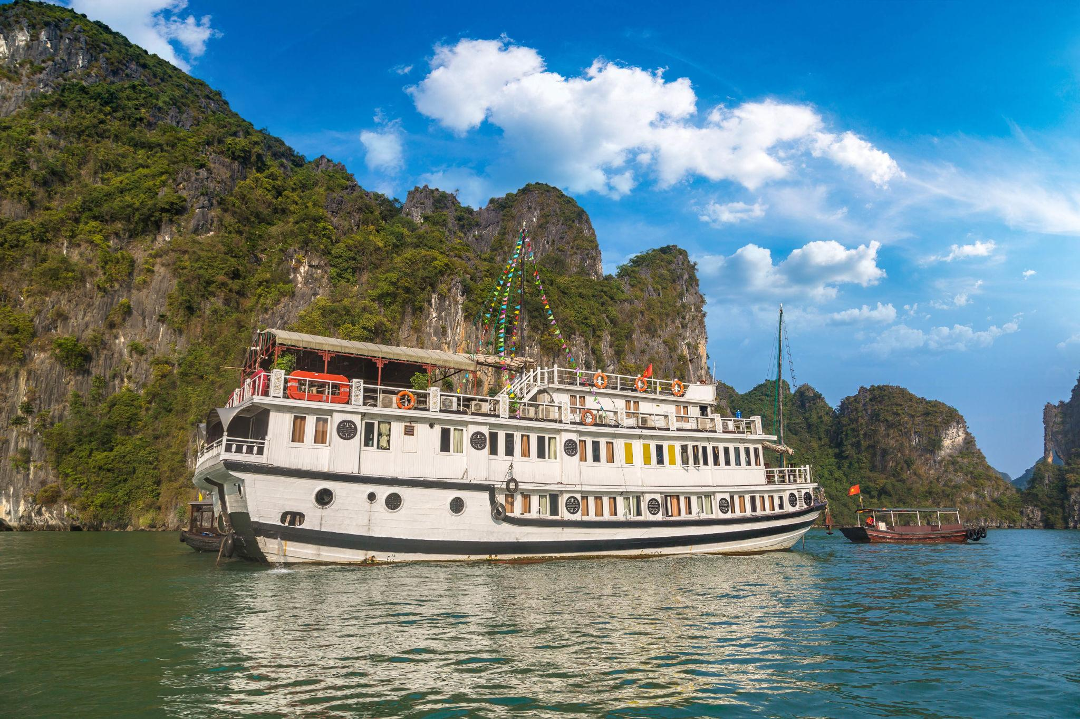
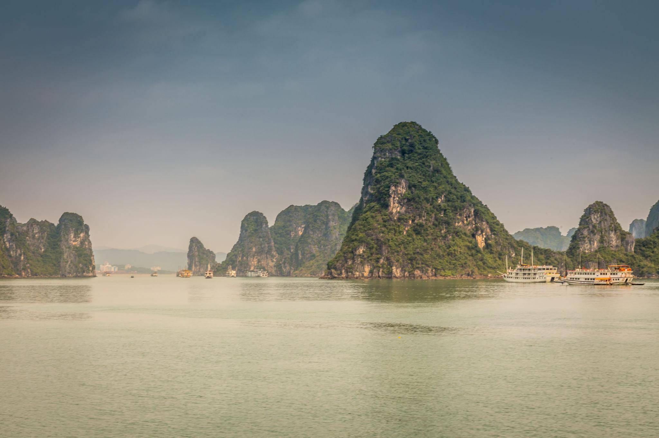
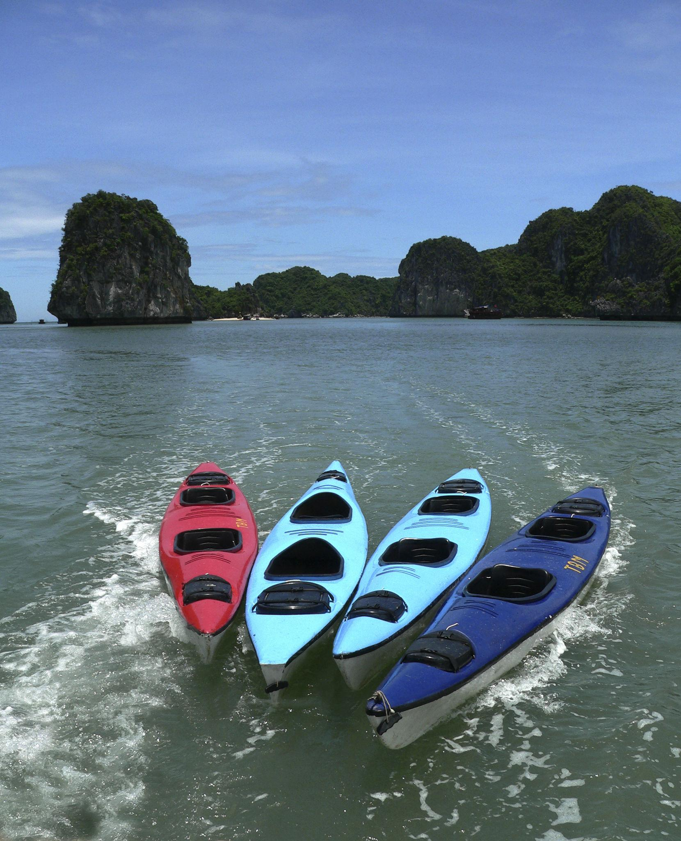

3. Hoi An
A charming ancient town known for lantern-lit streets and riverside beauty.
Must visit:
- Japanese Covered Bridge
- Lantern Market
- Riverside cafés
- Tailor shops
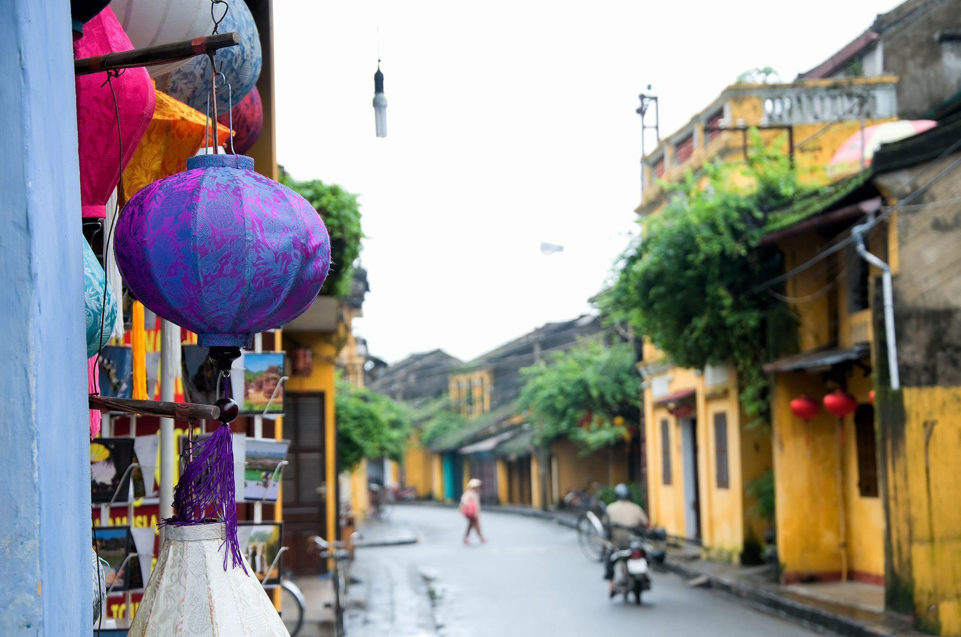
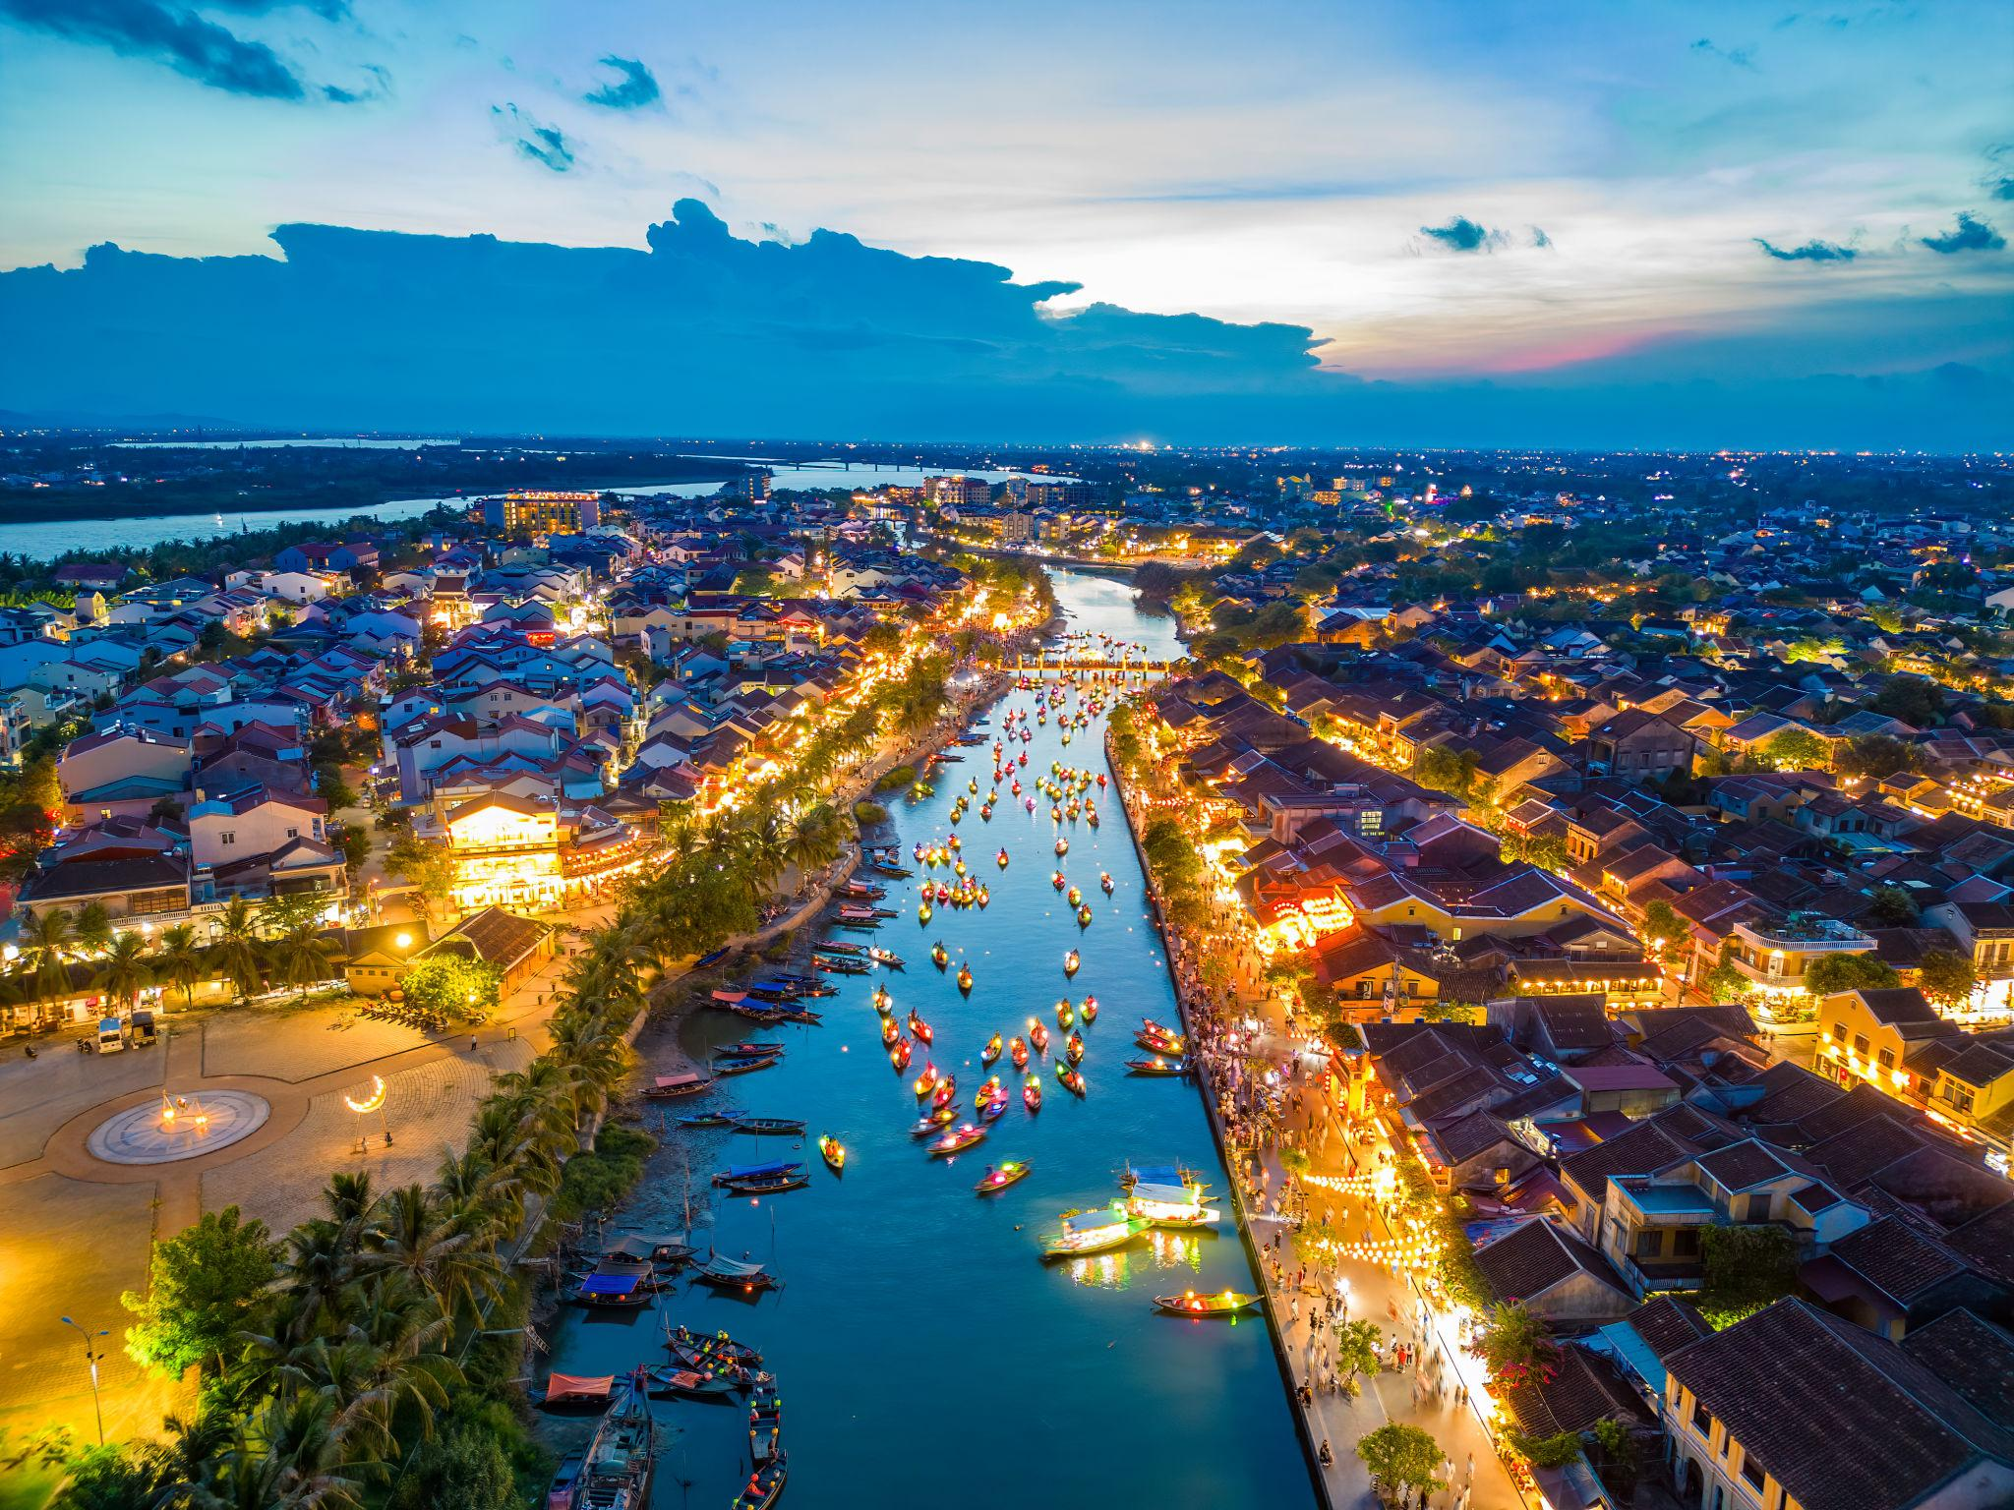
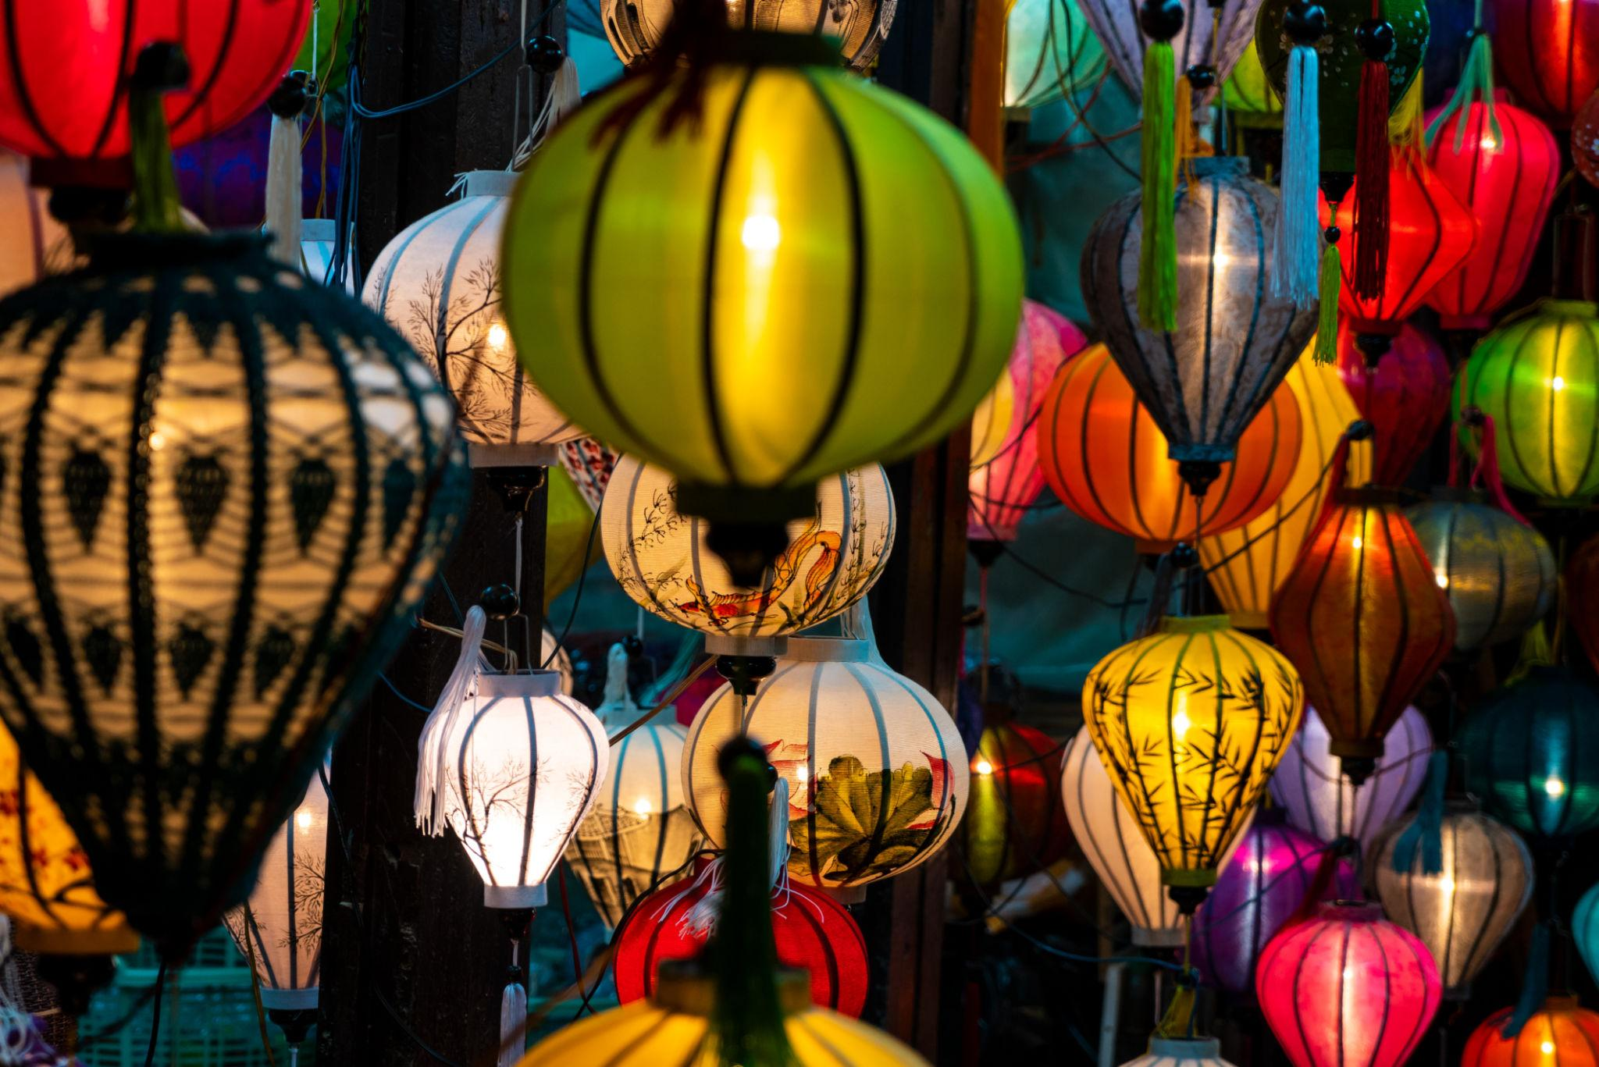
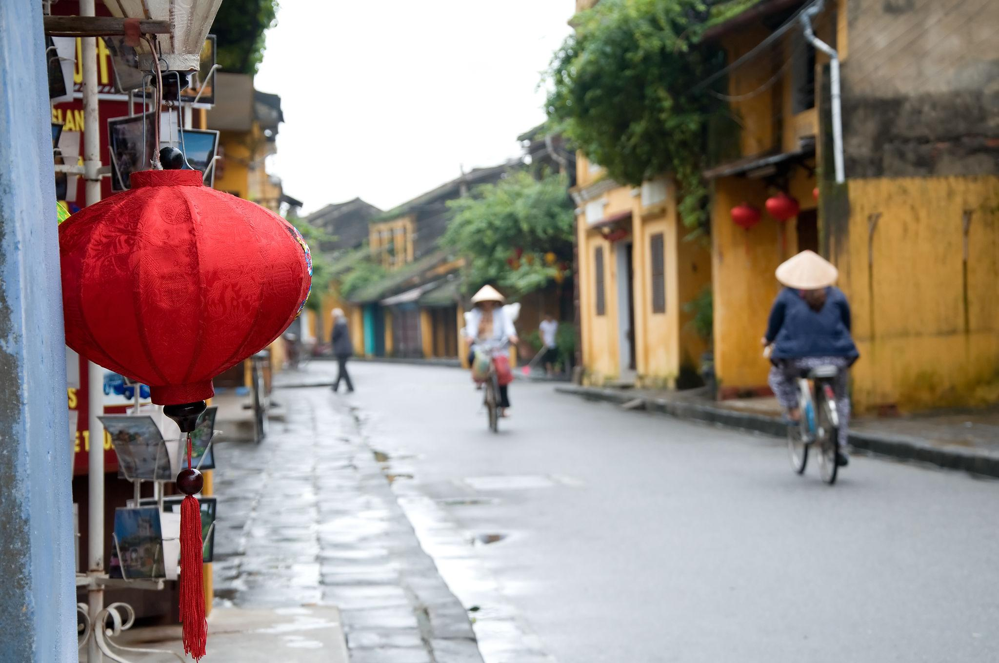
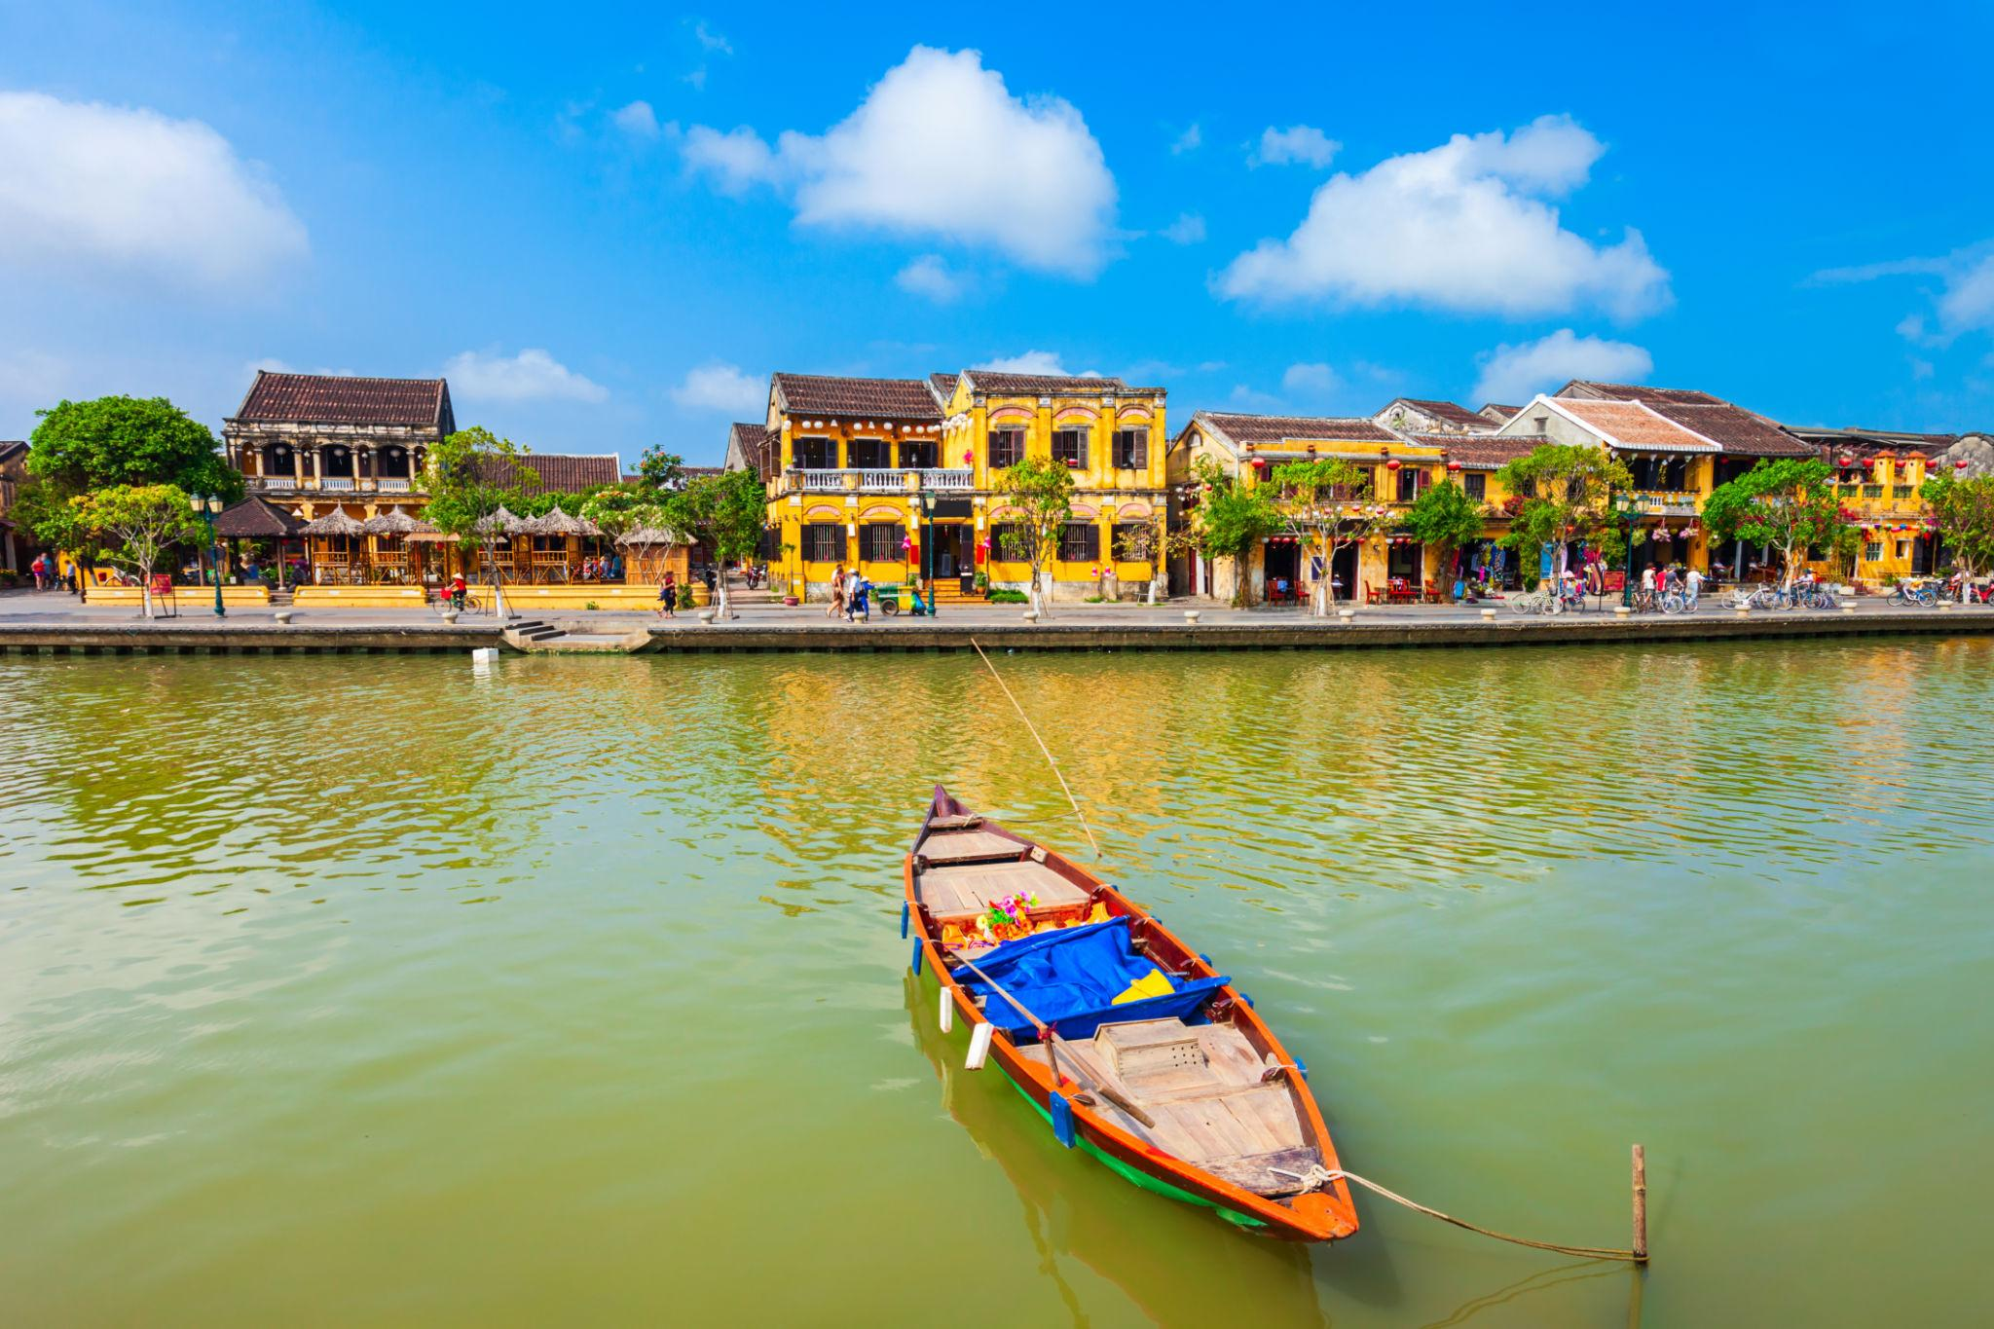
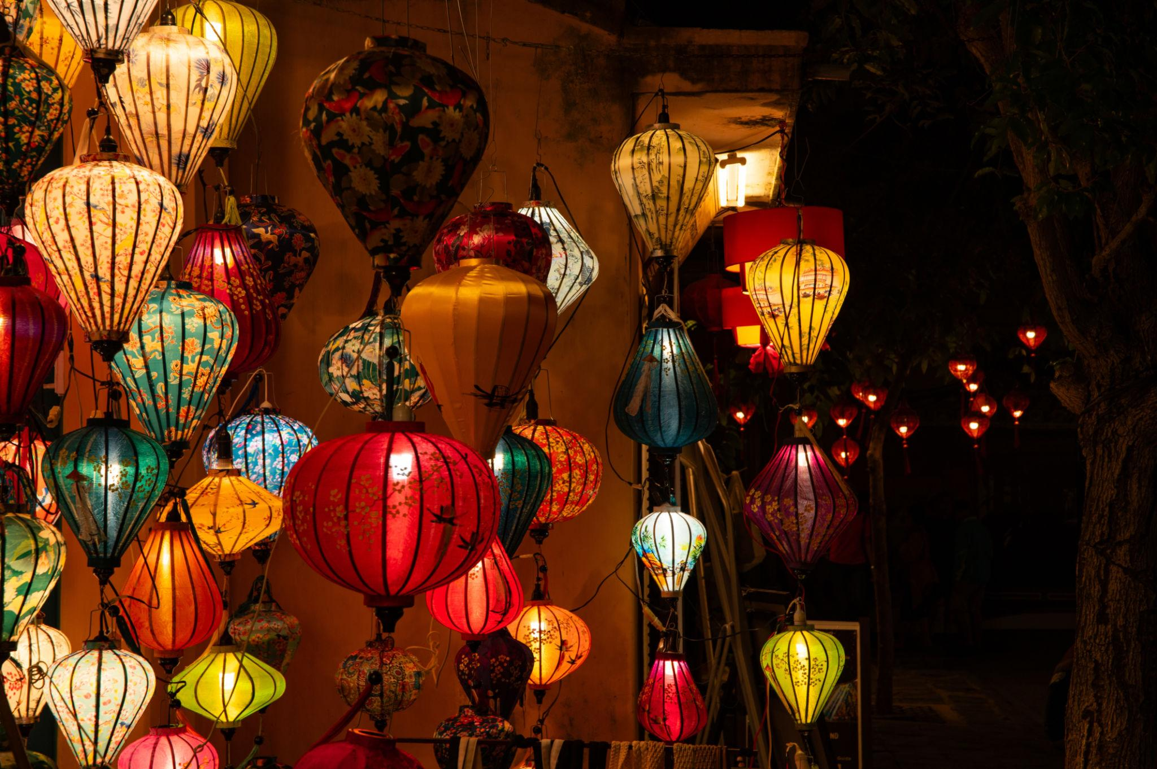

4. Ho Chi Minh City
Vietnam’s modern and energetic city known for shopping, nightlife, and history.
Highlights:
- Ben Thanh Market
- War Remnants Museum
- Notre-Dame Cathedral
- Rooftop cafés & nightlife
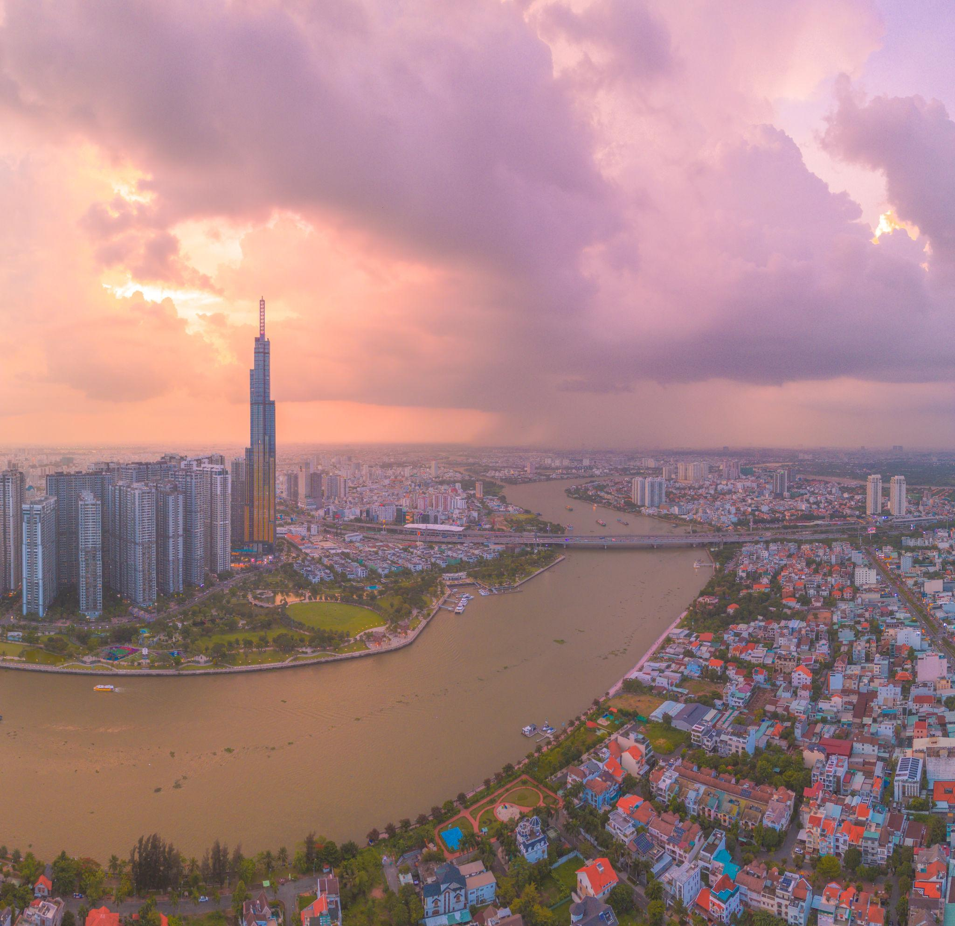
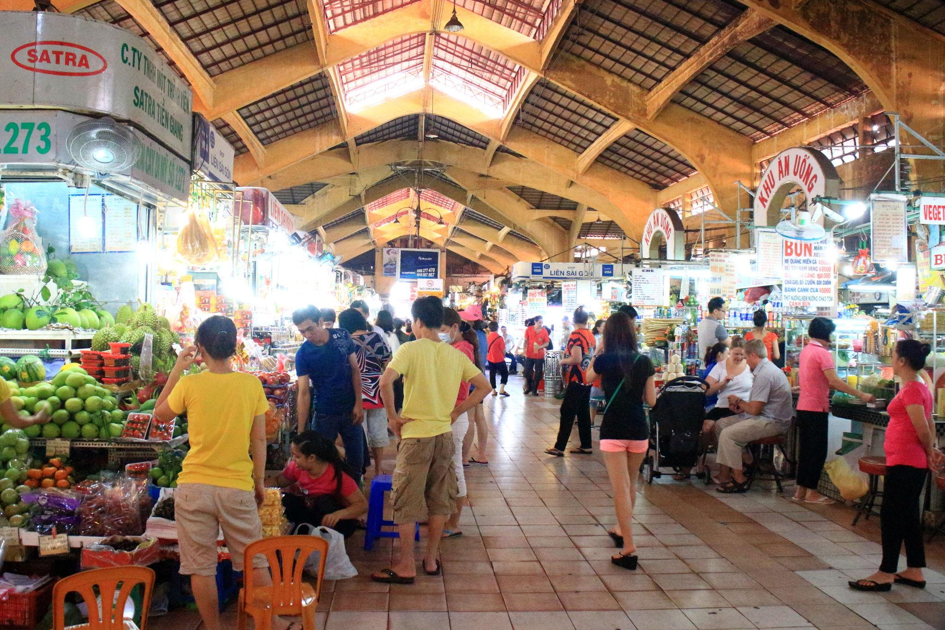
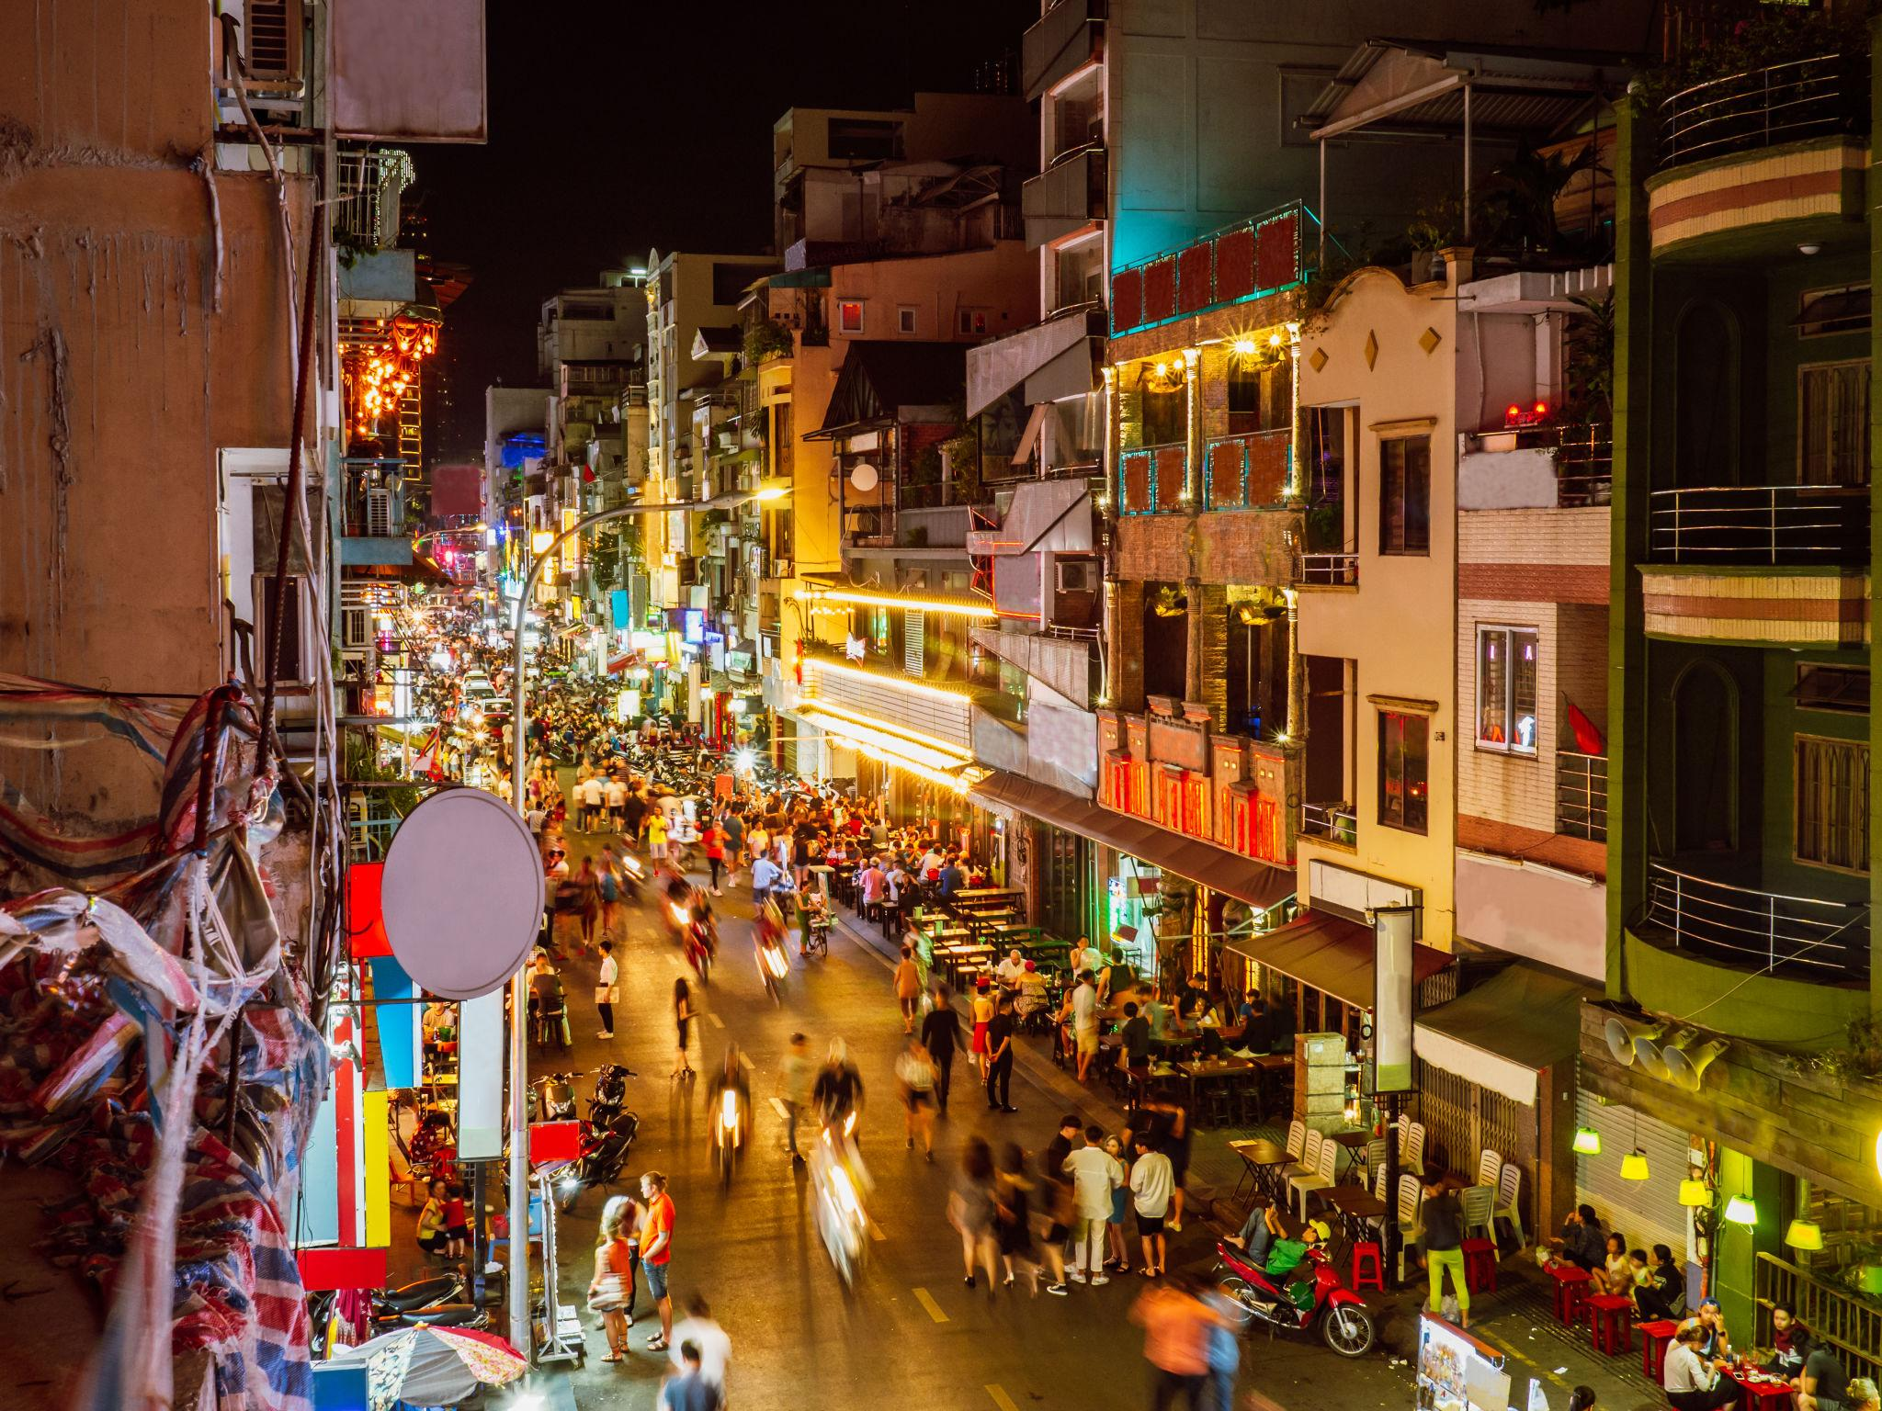
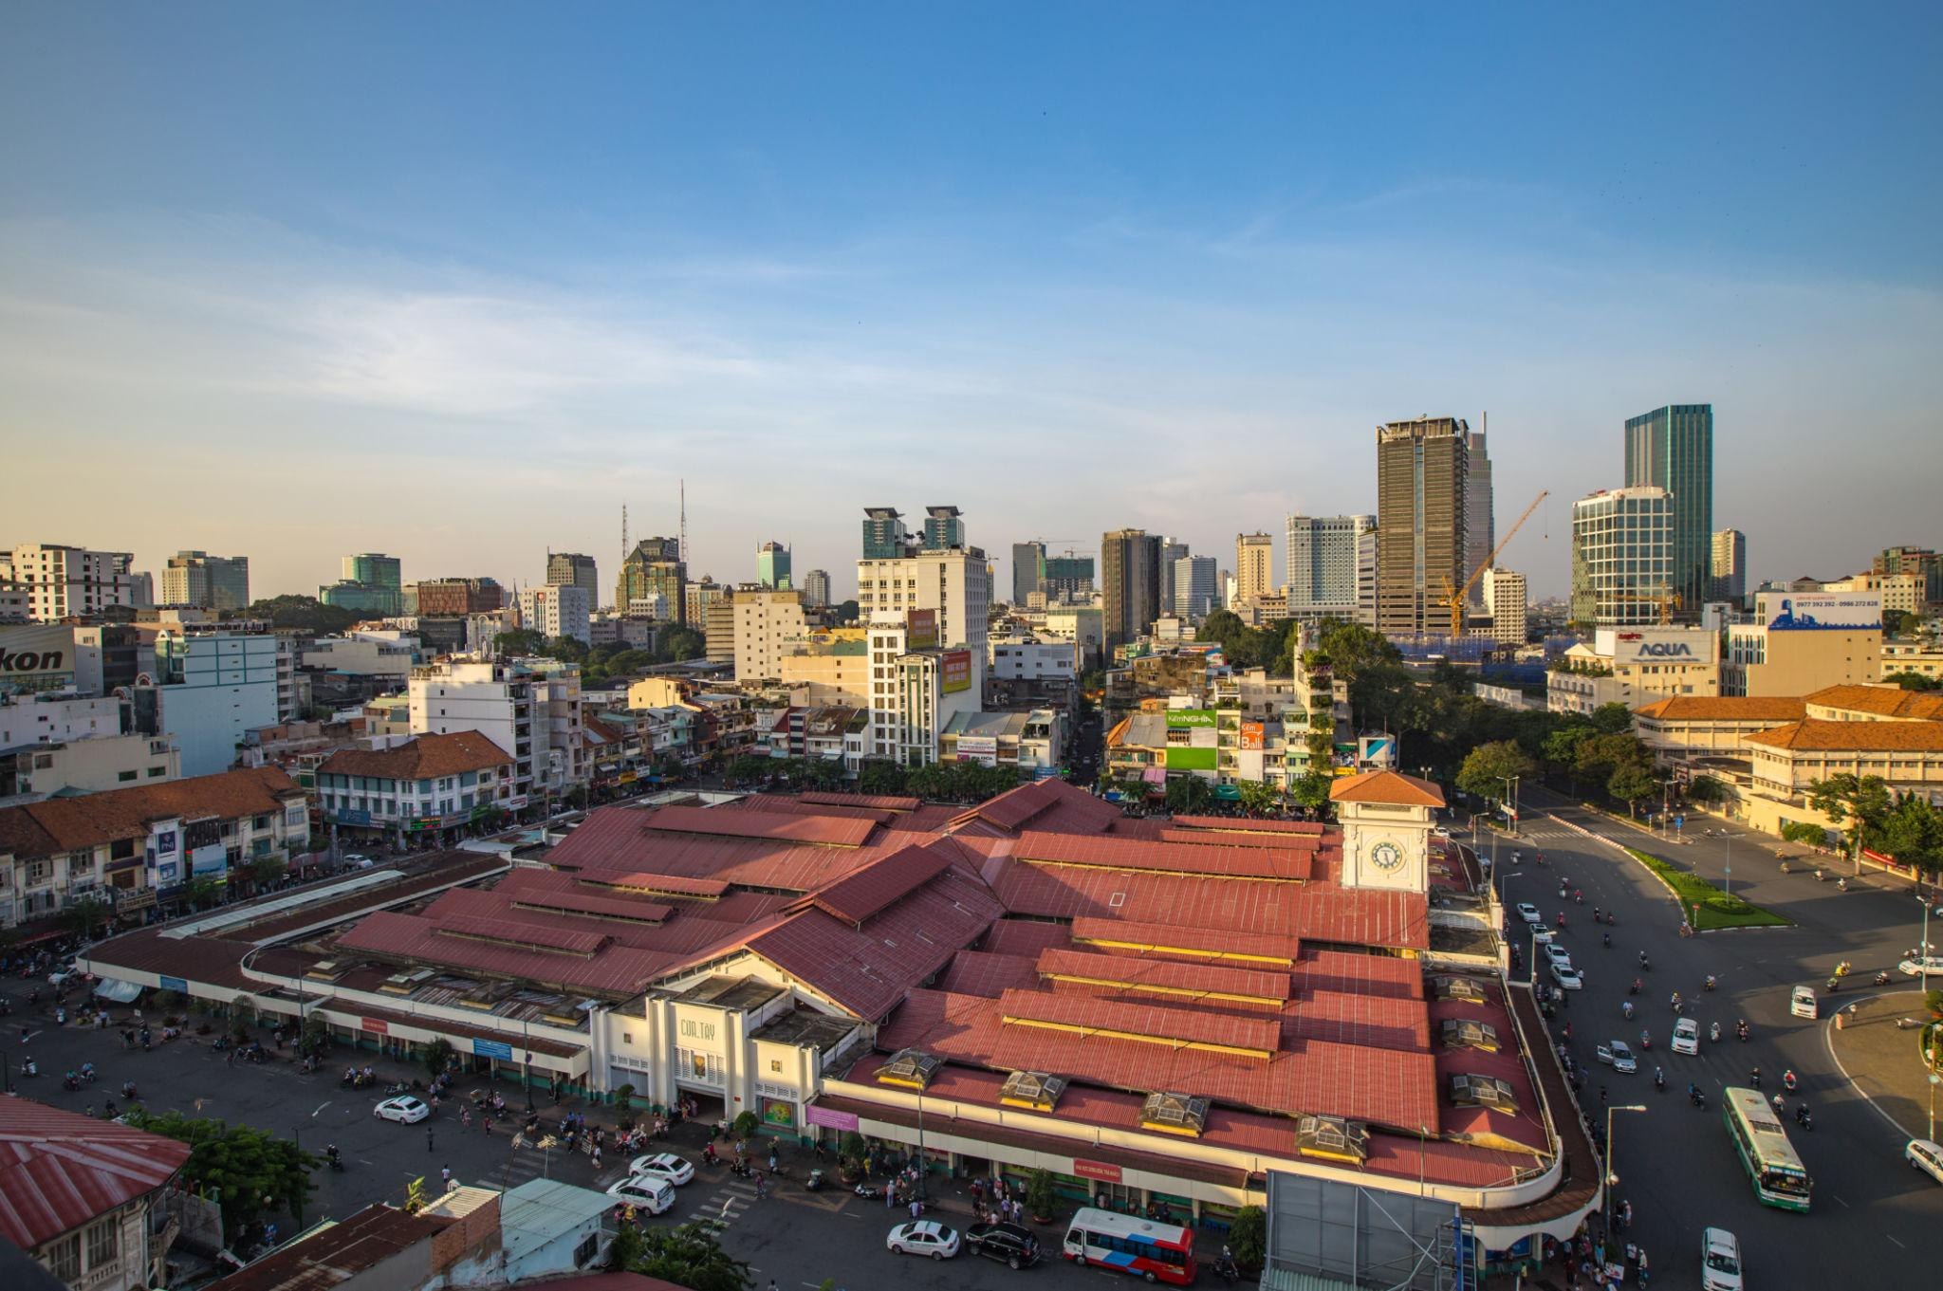
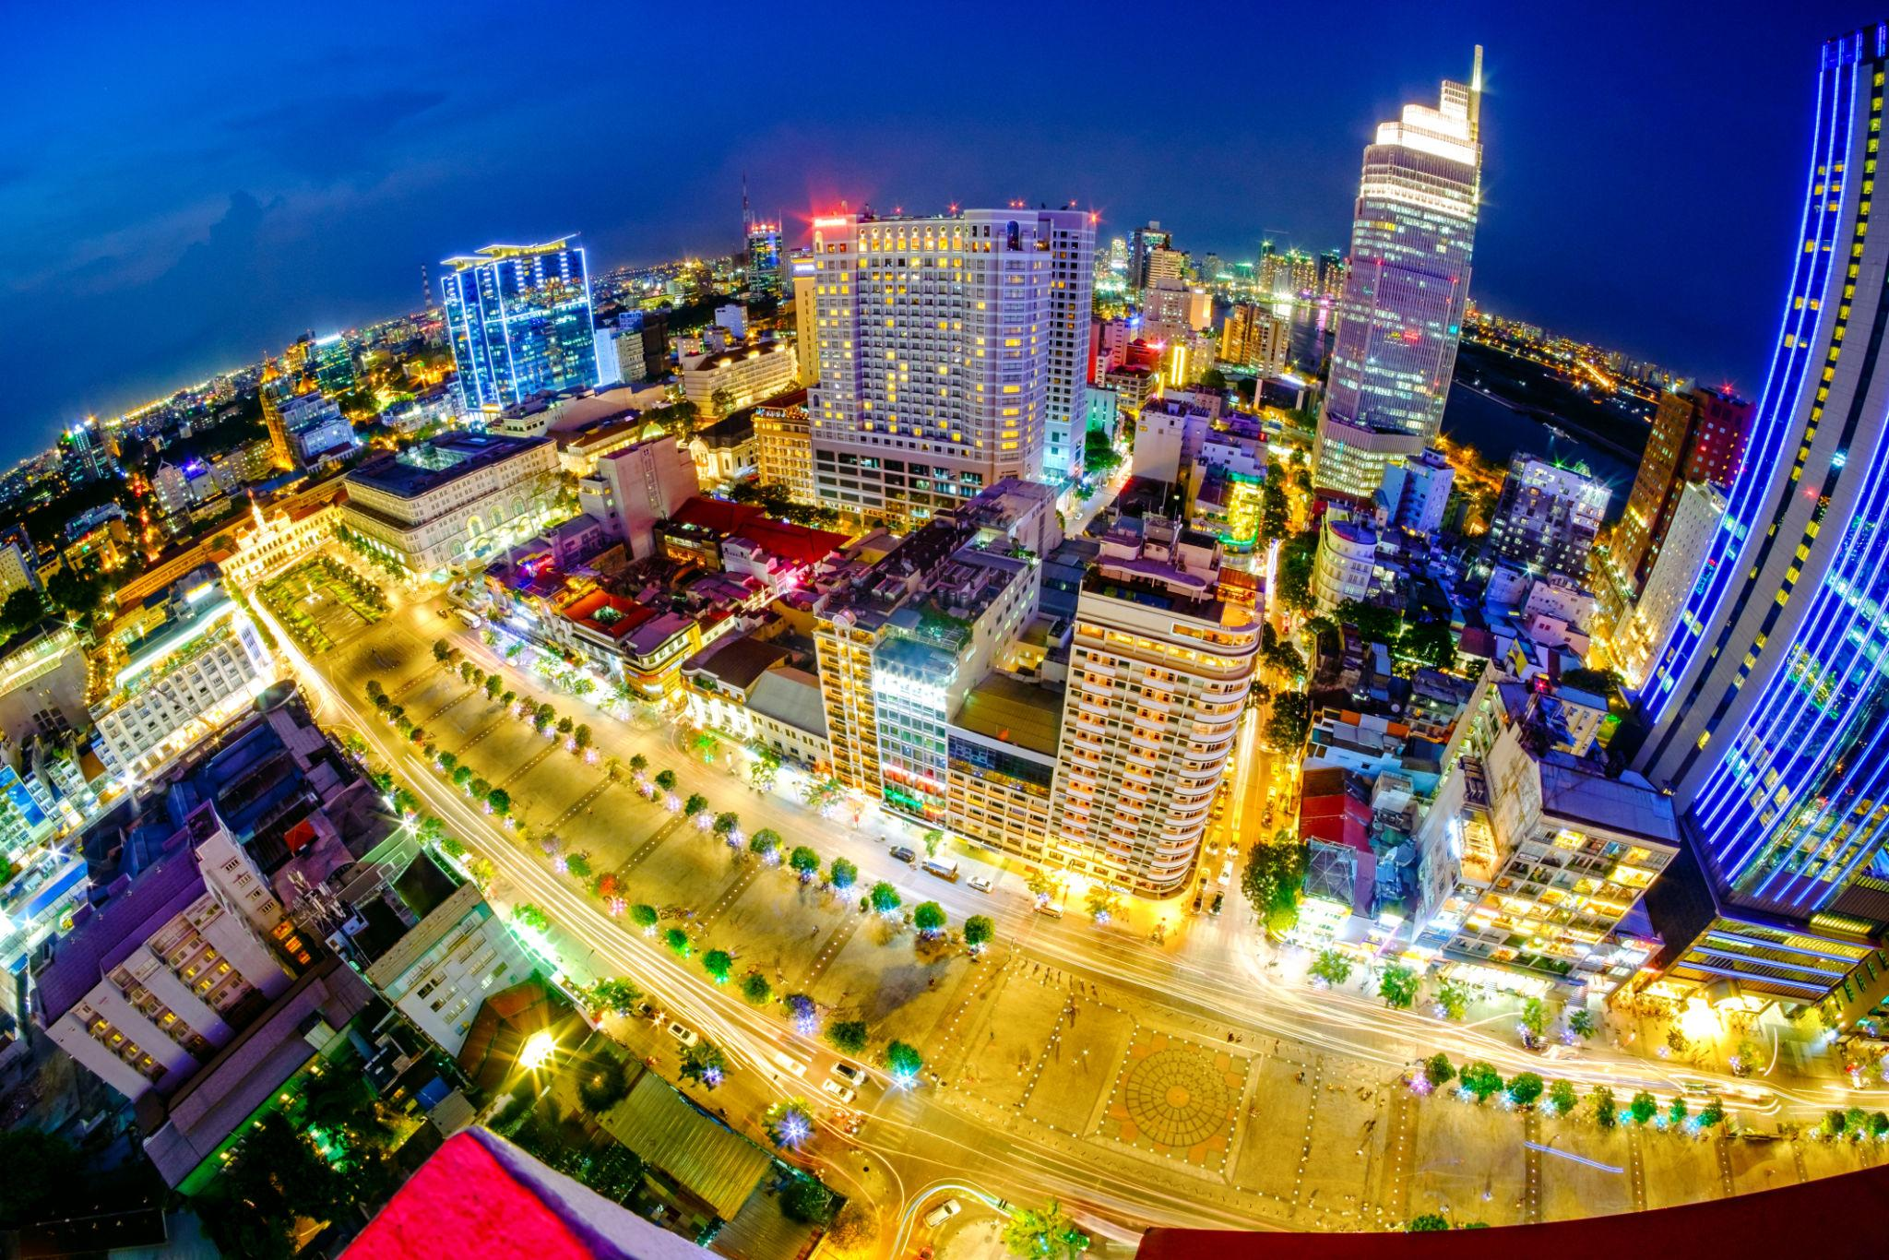
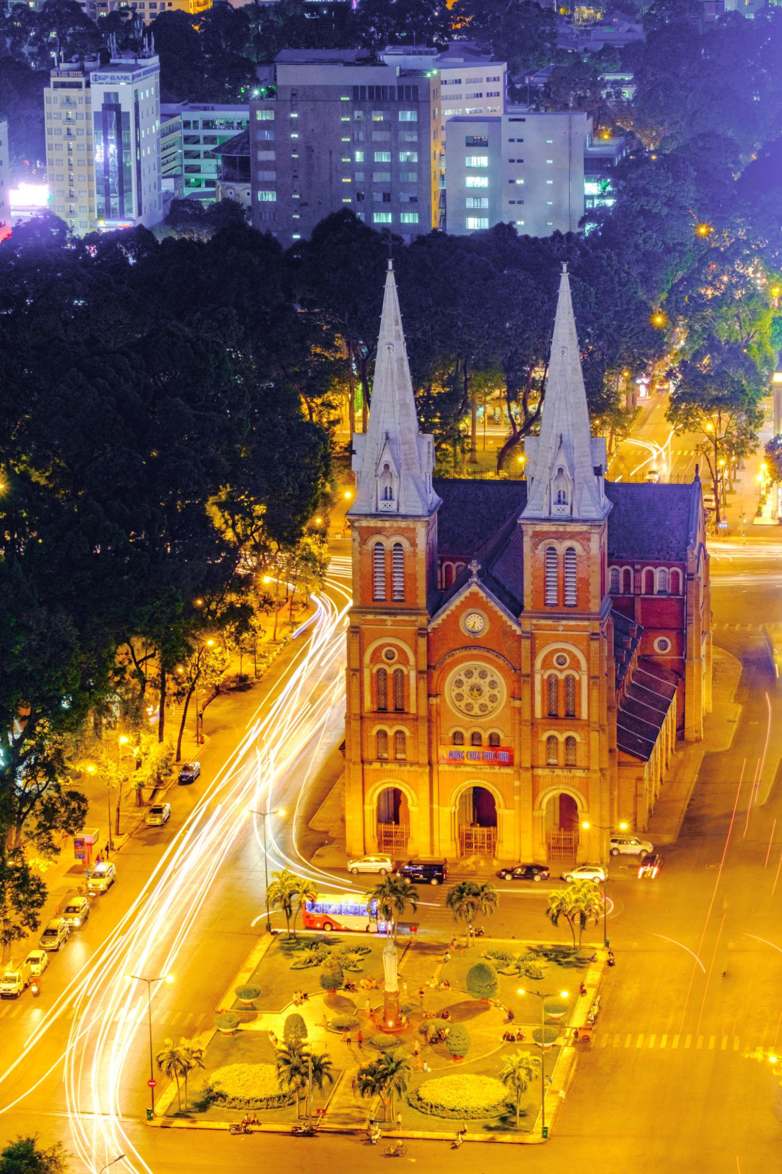

5. Da Nang
A beautiful coastal city famous for beaches and modern attractions.
Top attractions:
- Golden Bridge
- Ba Na Hills
- My Khe Beach
- Dragon Bridge
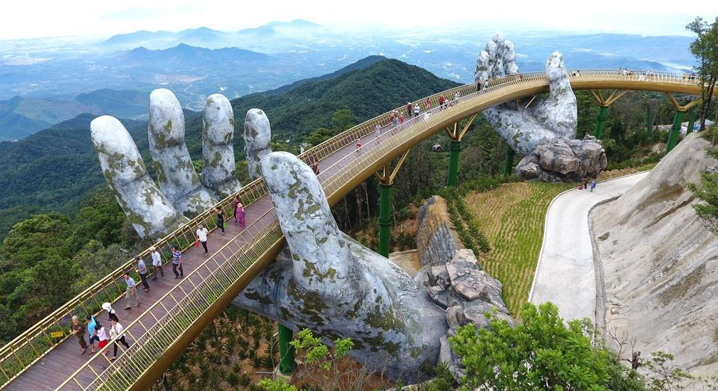
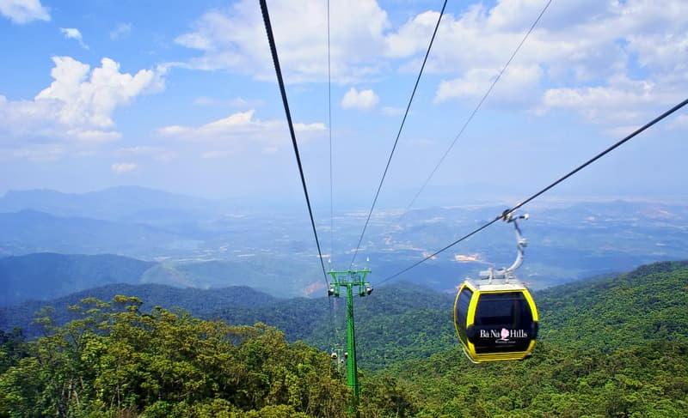
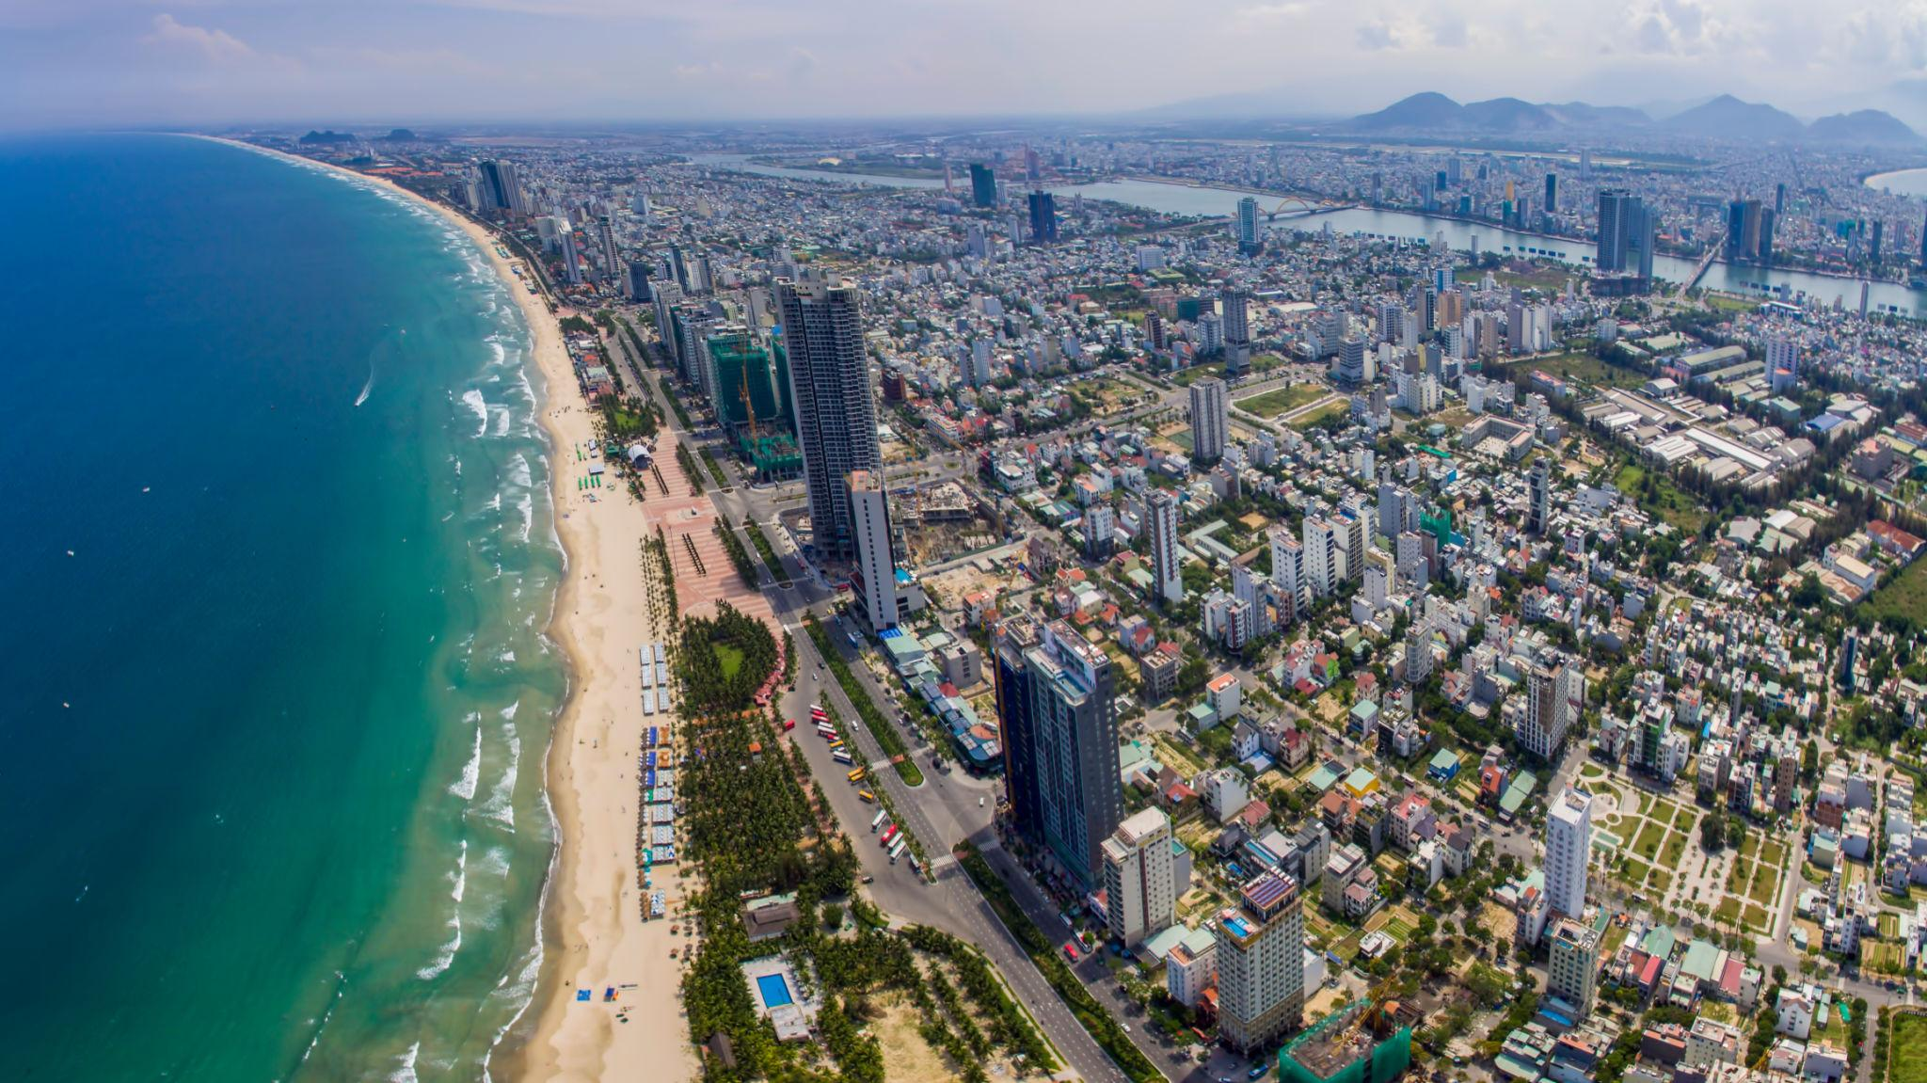
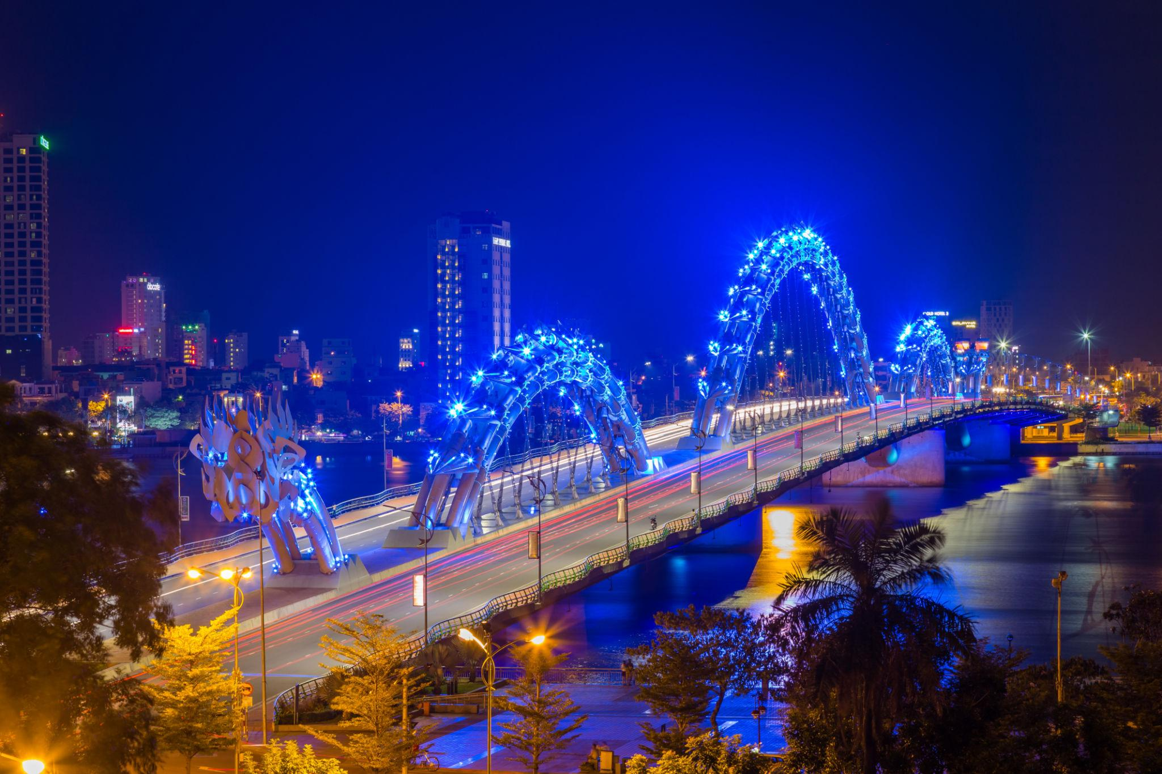
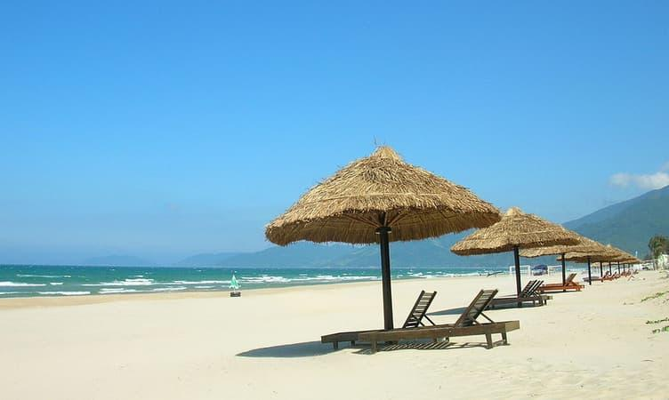

6. Sapa
A mountain paradise famous for rice terraces and trekking.
Best experiences:
- Trekking tours
- Ethnic village visits
- Mountain landscapes
- Scenic photography
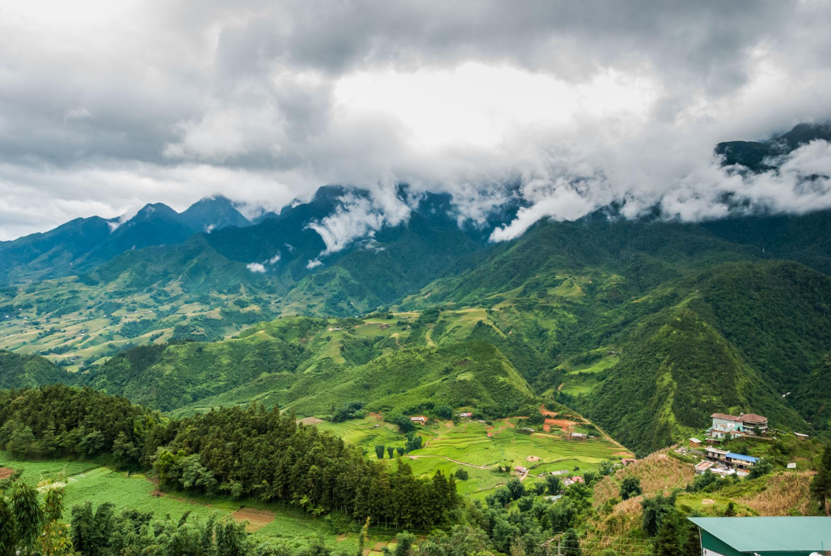
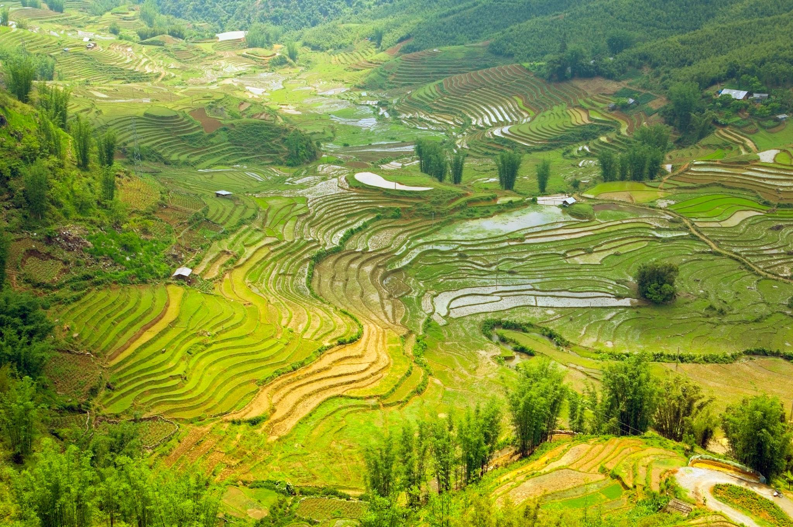
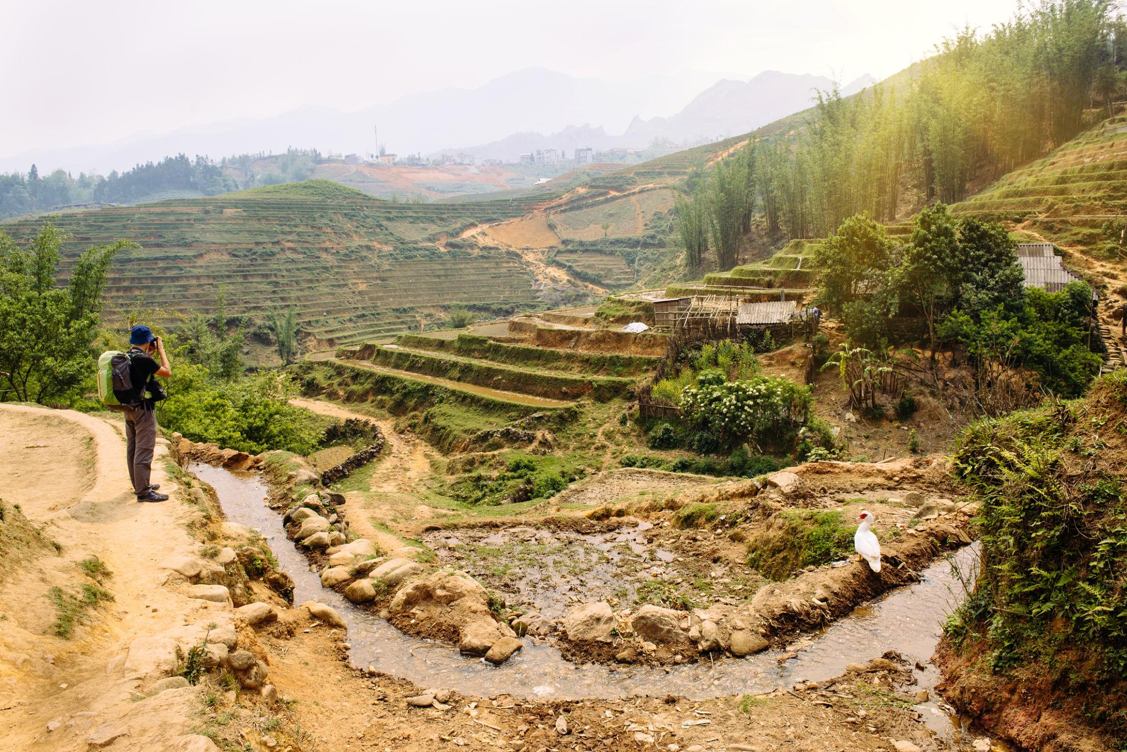
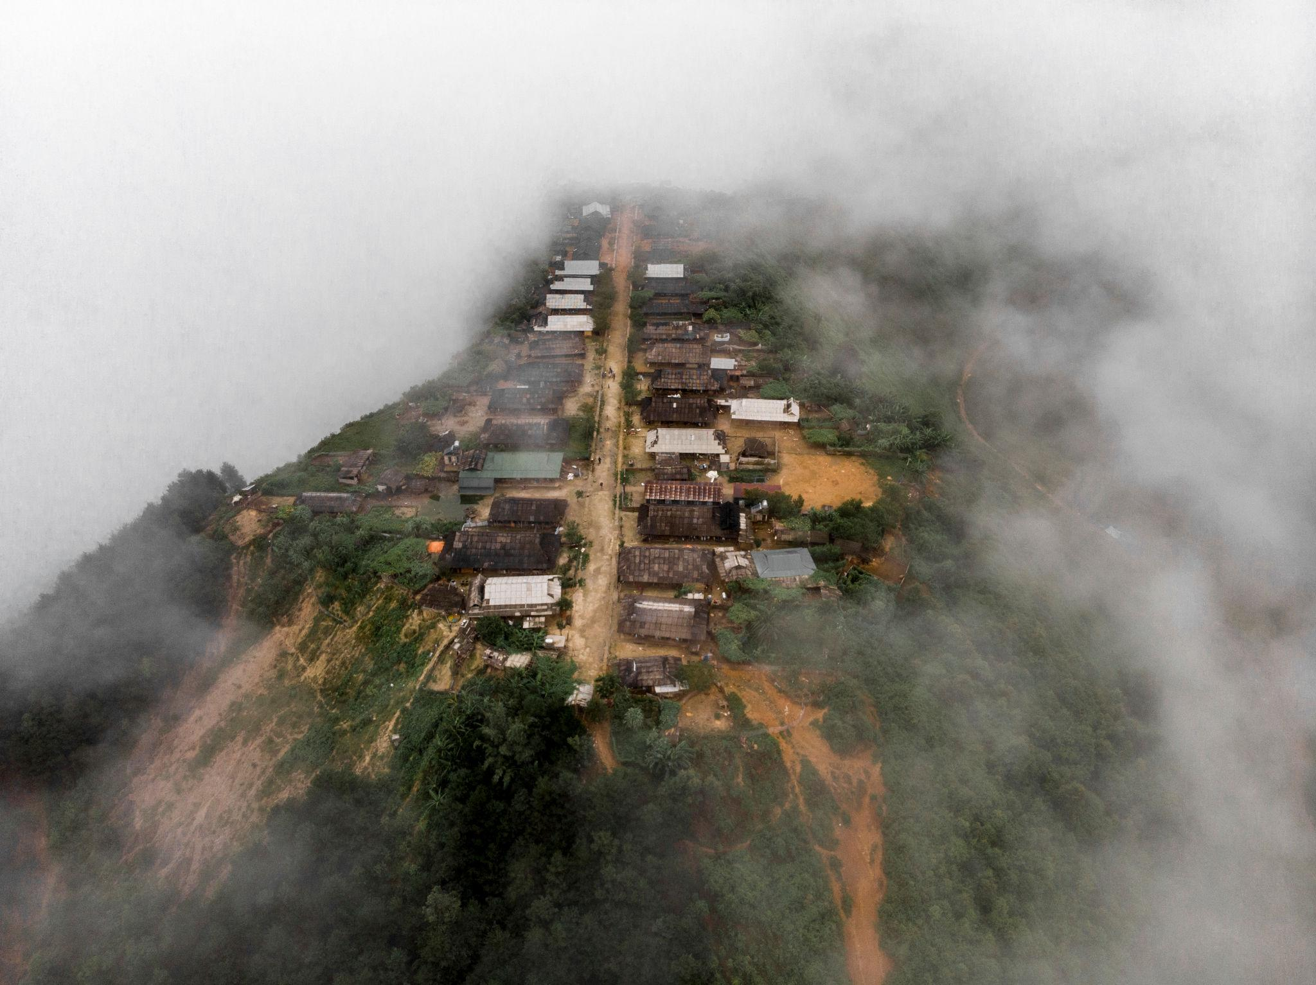
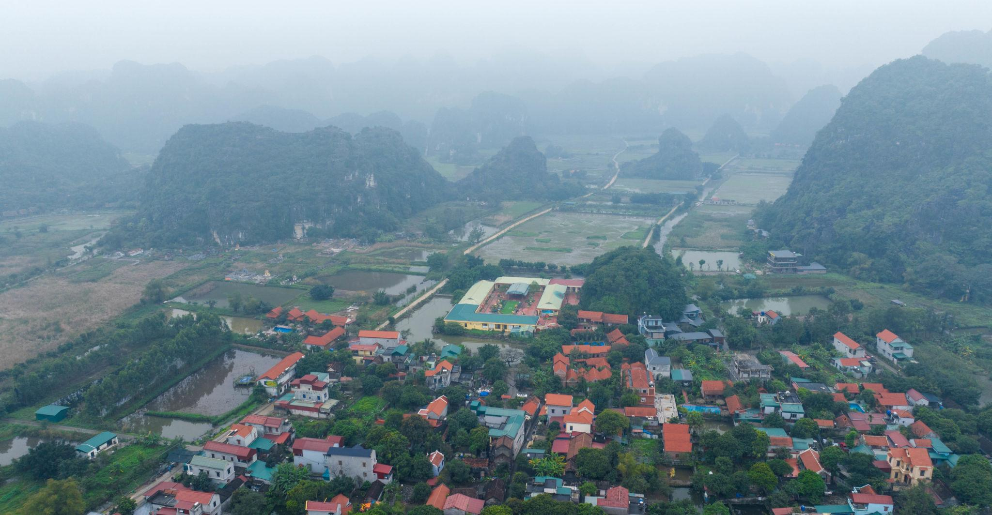
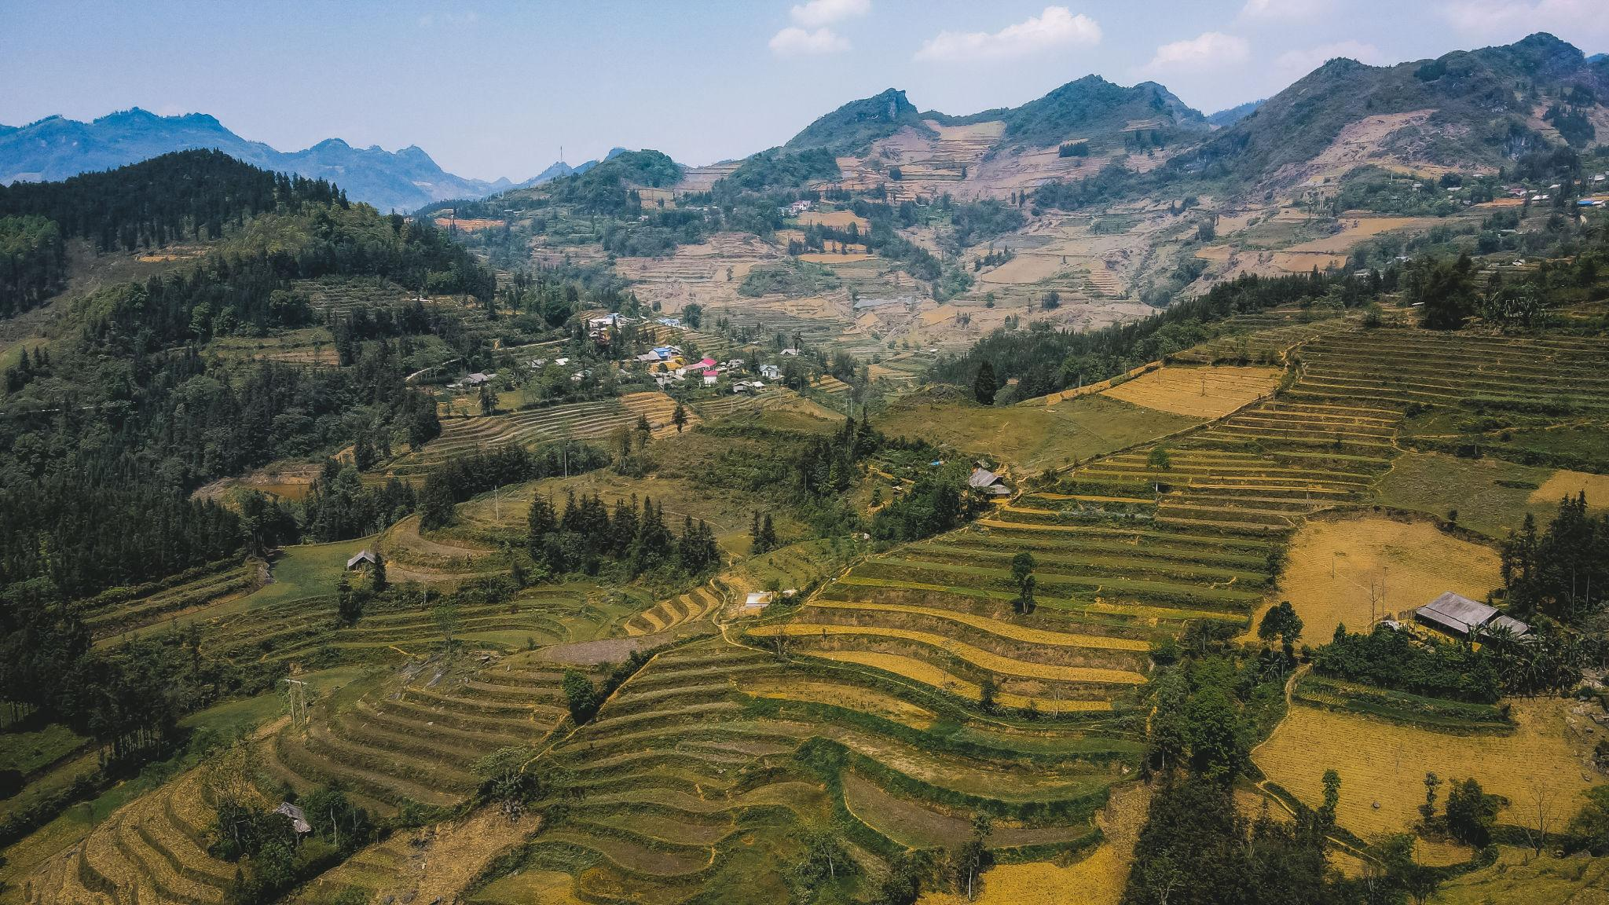

Best Things to Do in Vietnam
- Cruise through Ha Long Bay
- Explore lantern streets of Hoi An
- Ride cable cars at Ba Na Hills
- Try Vietnamese street food
- Visit floating markets
- Enjoy beach resorts in Da Nang & Phu Quoc
- Experience Vietnamese coffee culture
- Explore ancient temples & history museums
- Trek in Sapa mountains
- Shop in local markets

Best Time to Visit Vietnam
Region | Best Time
North Vietnam | October – April
Central Vietnam | February – August
South Vietnam | November – April
Vietnam has different climate zones, making it a year-round destination.

Vietnam Visa for Indians 🇮🇳
Indian travelers generally require:
- Passport valid for 6 months
- Vietnam e-Visa
- Return flight tickets
- Hotel bookings
- Travel insurance

Famous Vietnamese Foods to Try 🍜
- Pho
- Banh Mi
- Spring Rolls
- Vietnamese Coffee
- Bun Cha
- Seafood Hotpot
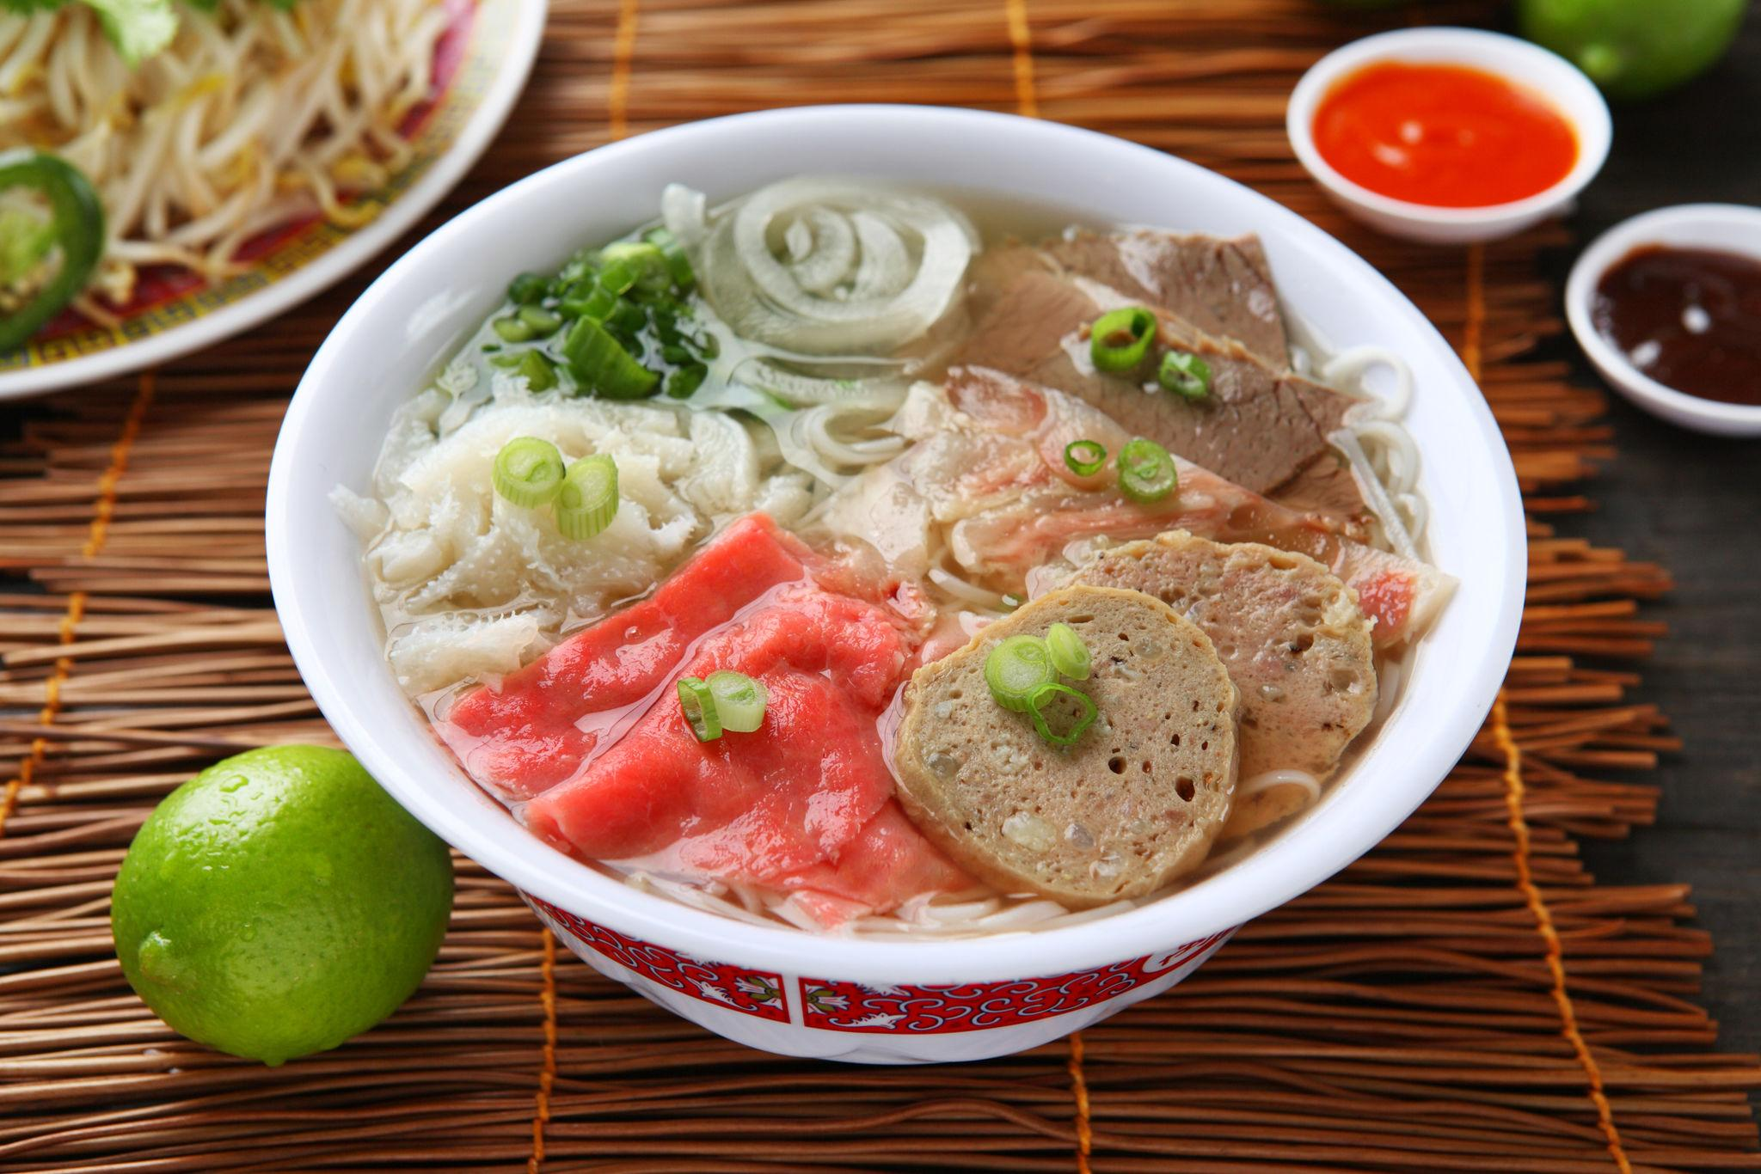
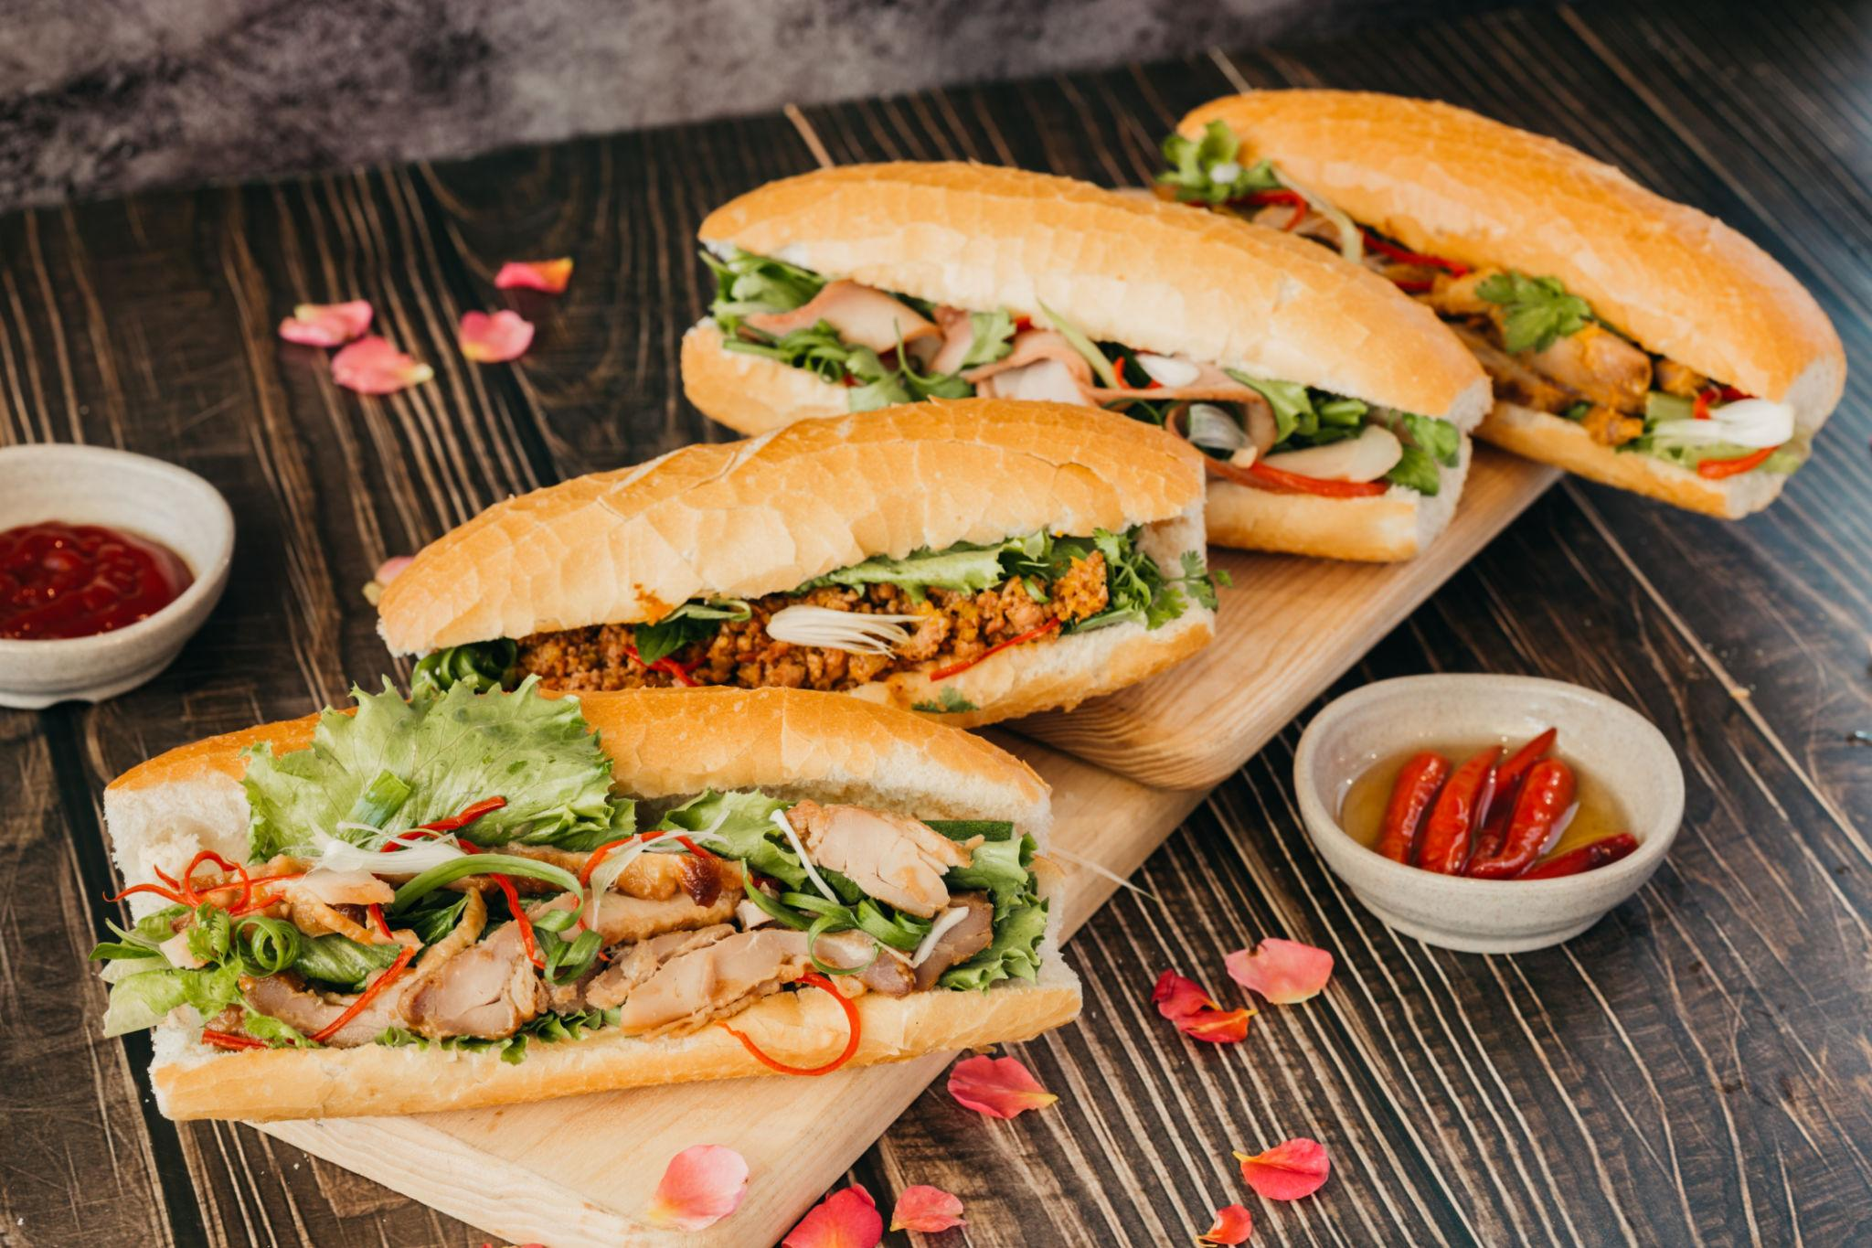
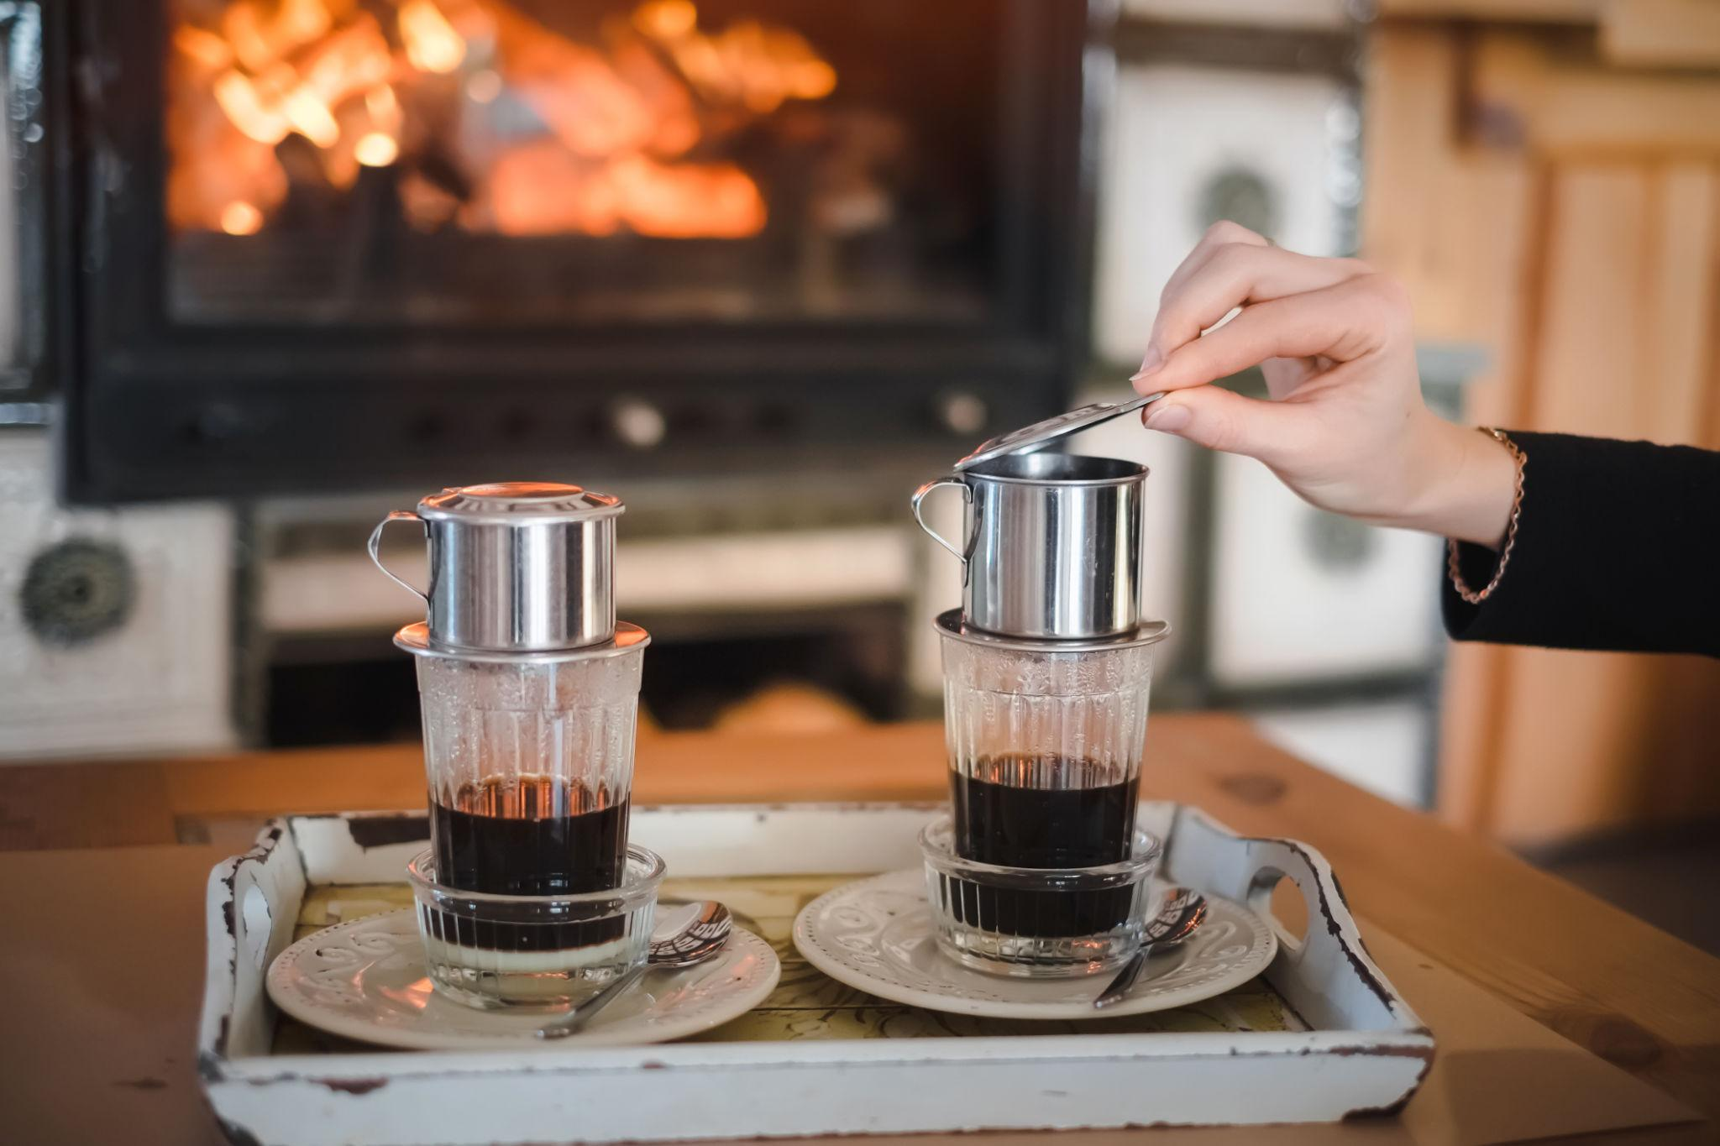
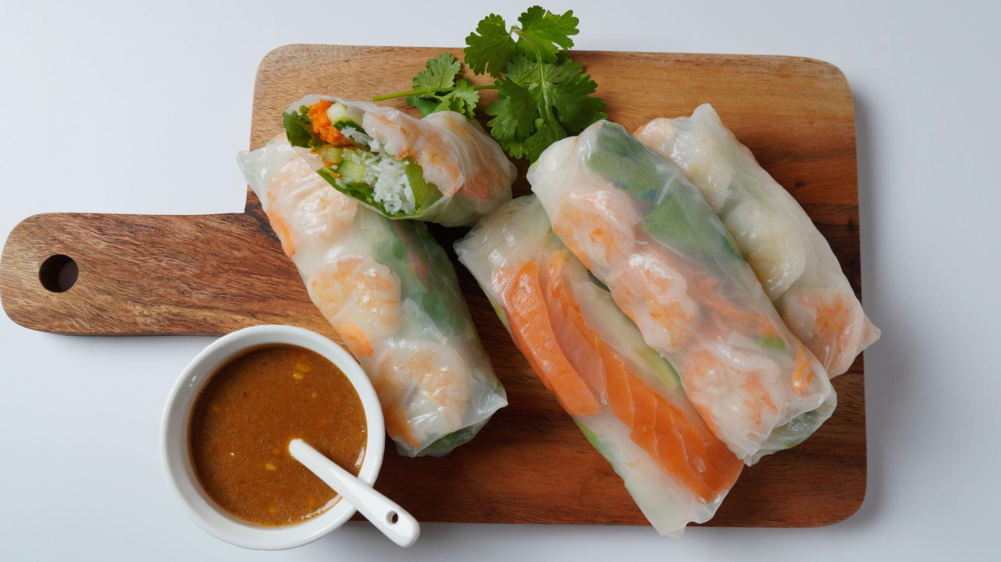
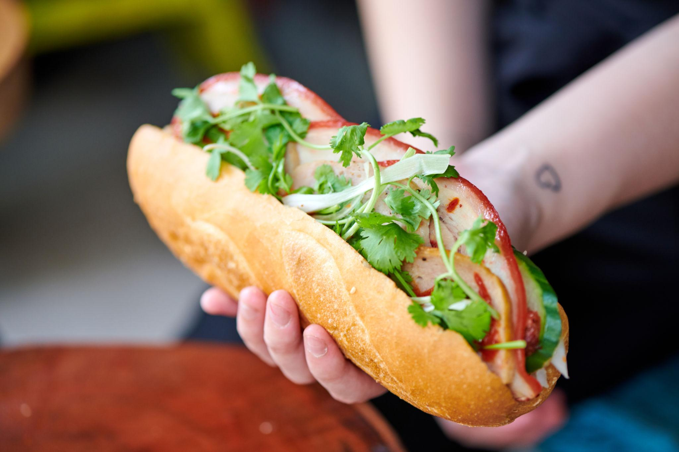
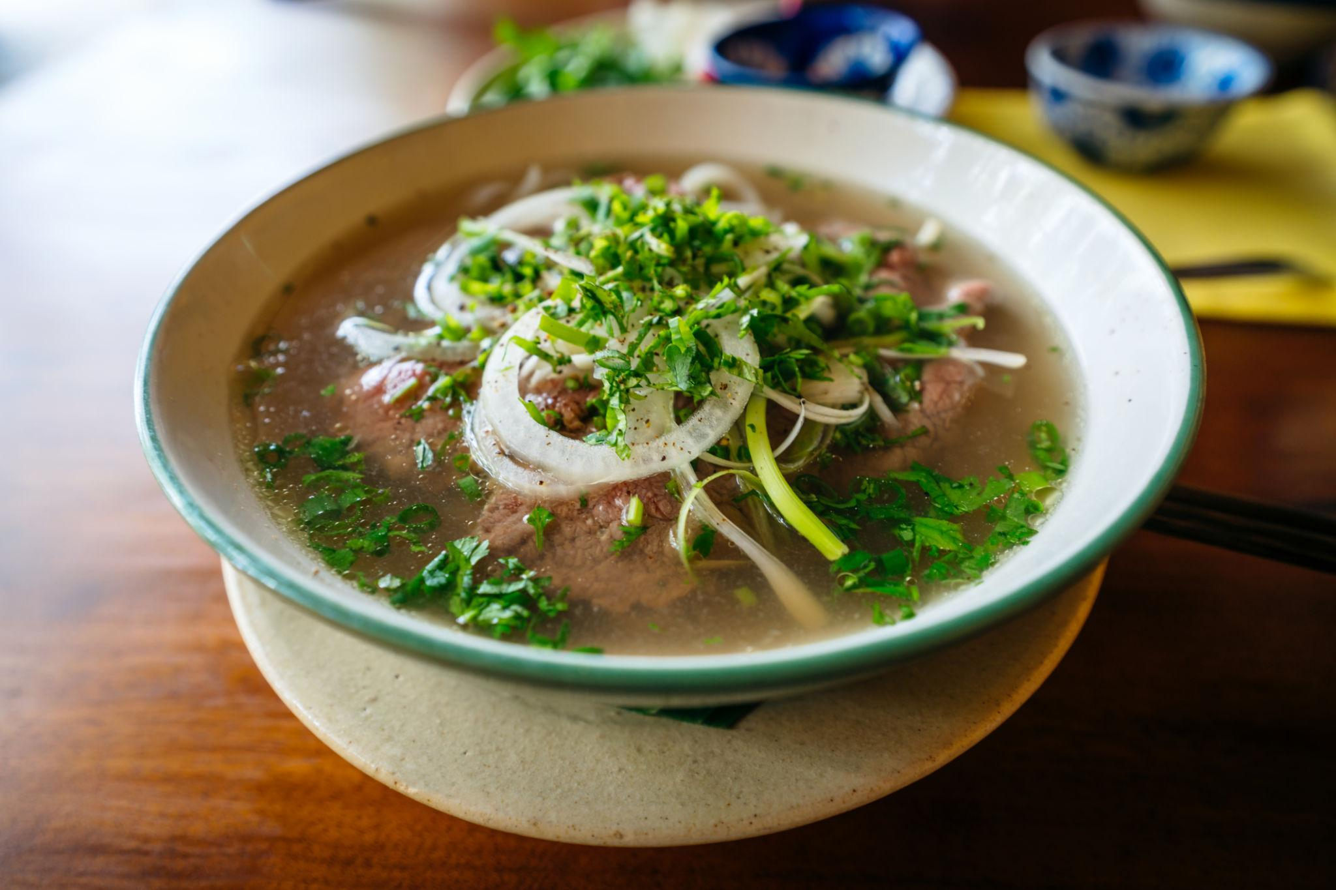

Luxury Experiences in Vietnam ✨
- Luxury Ha Long Bay cruises
- Beachfront resorts in Da Nang
- Private lantern boat rides
- Spa & wellness retreats
- Rooftop fine dining
- Private island tours
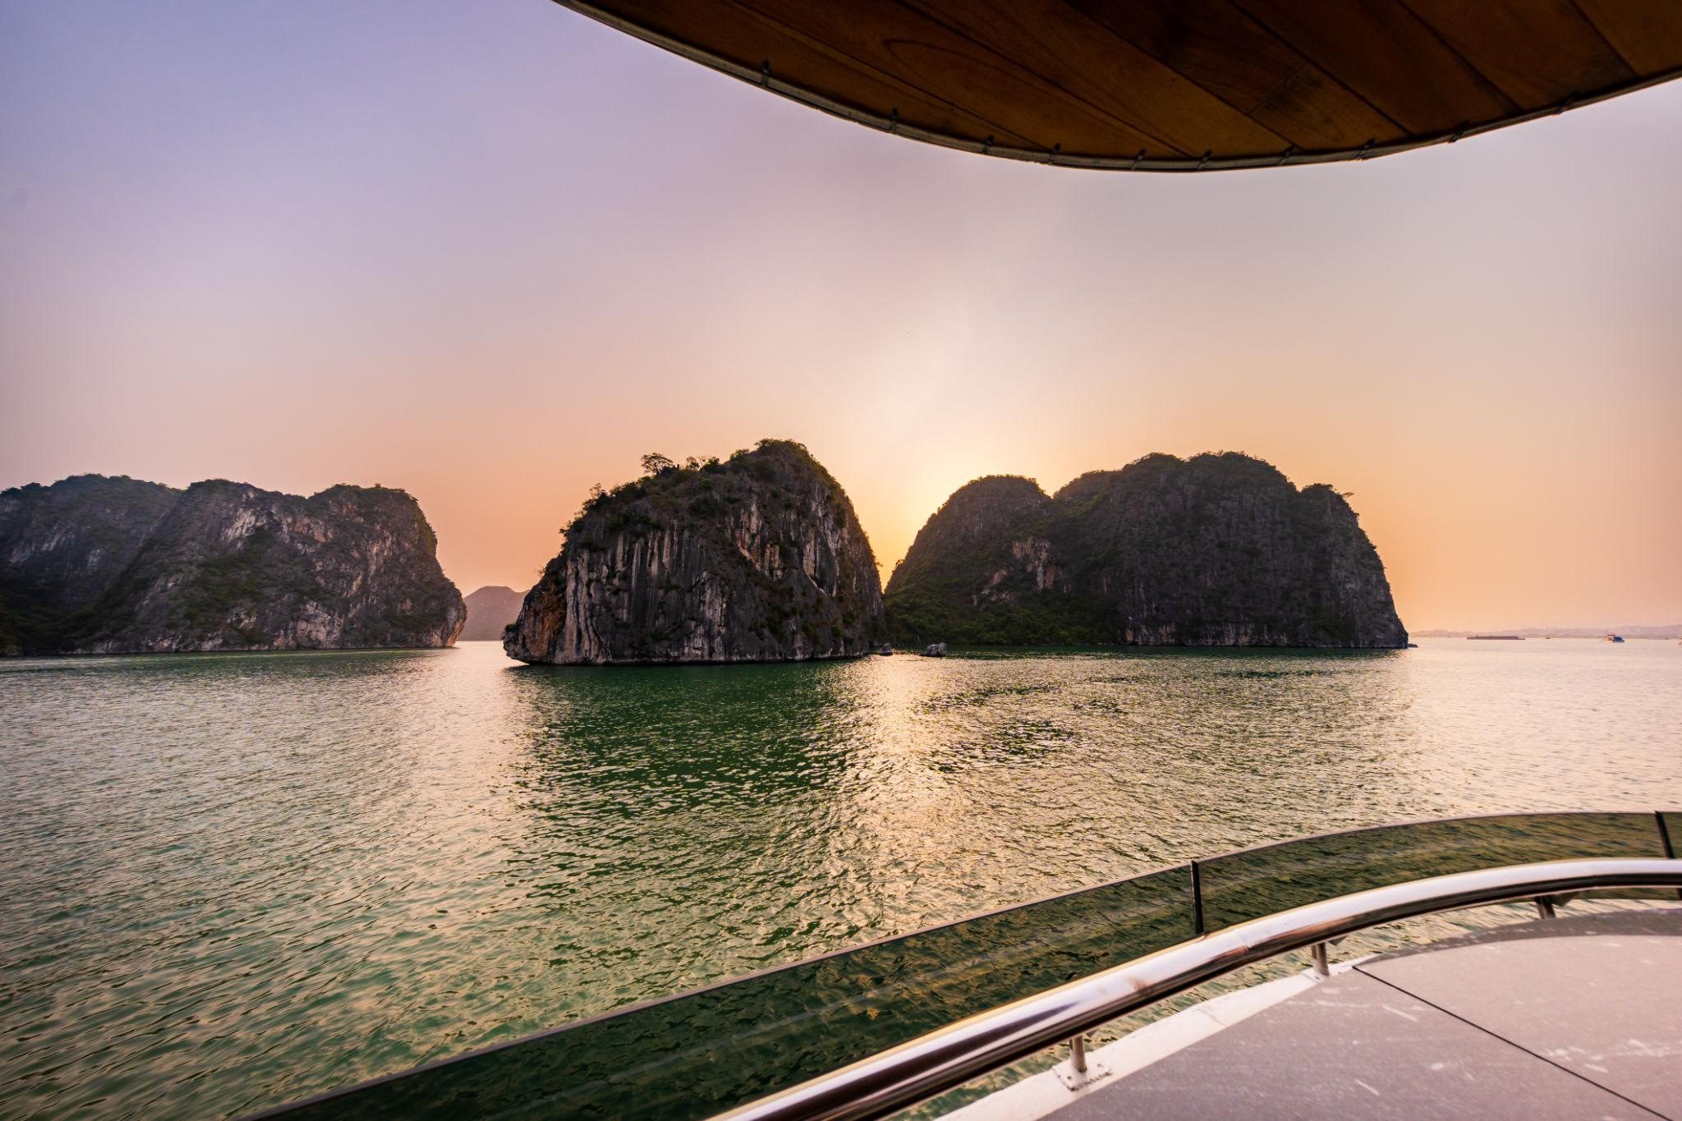
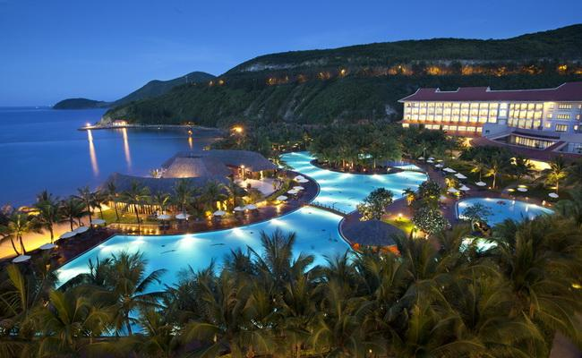
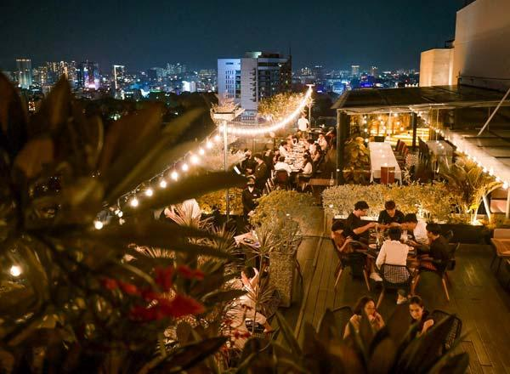
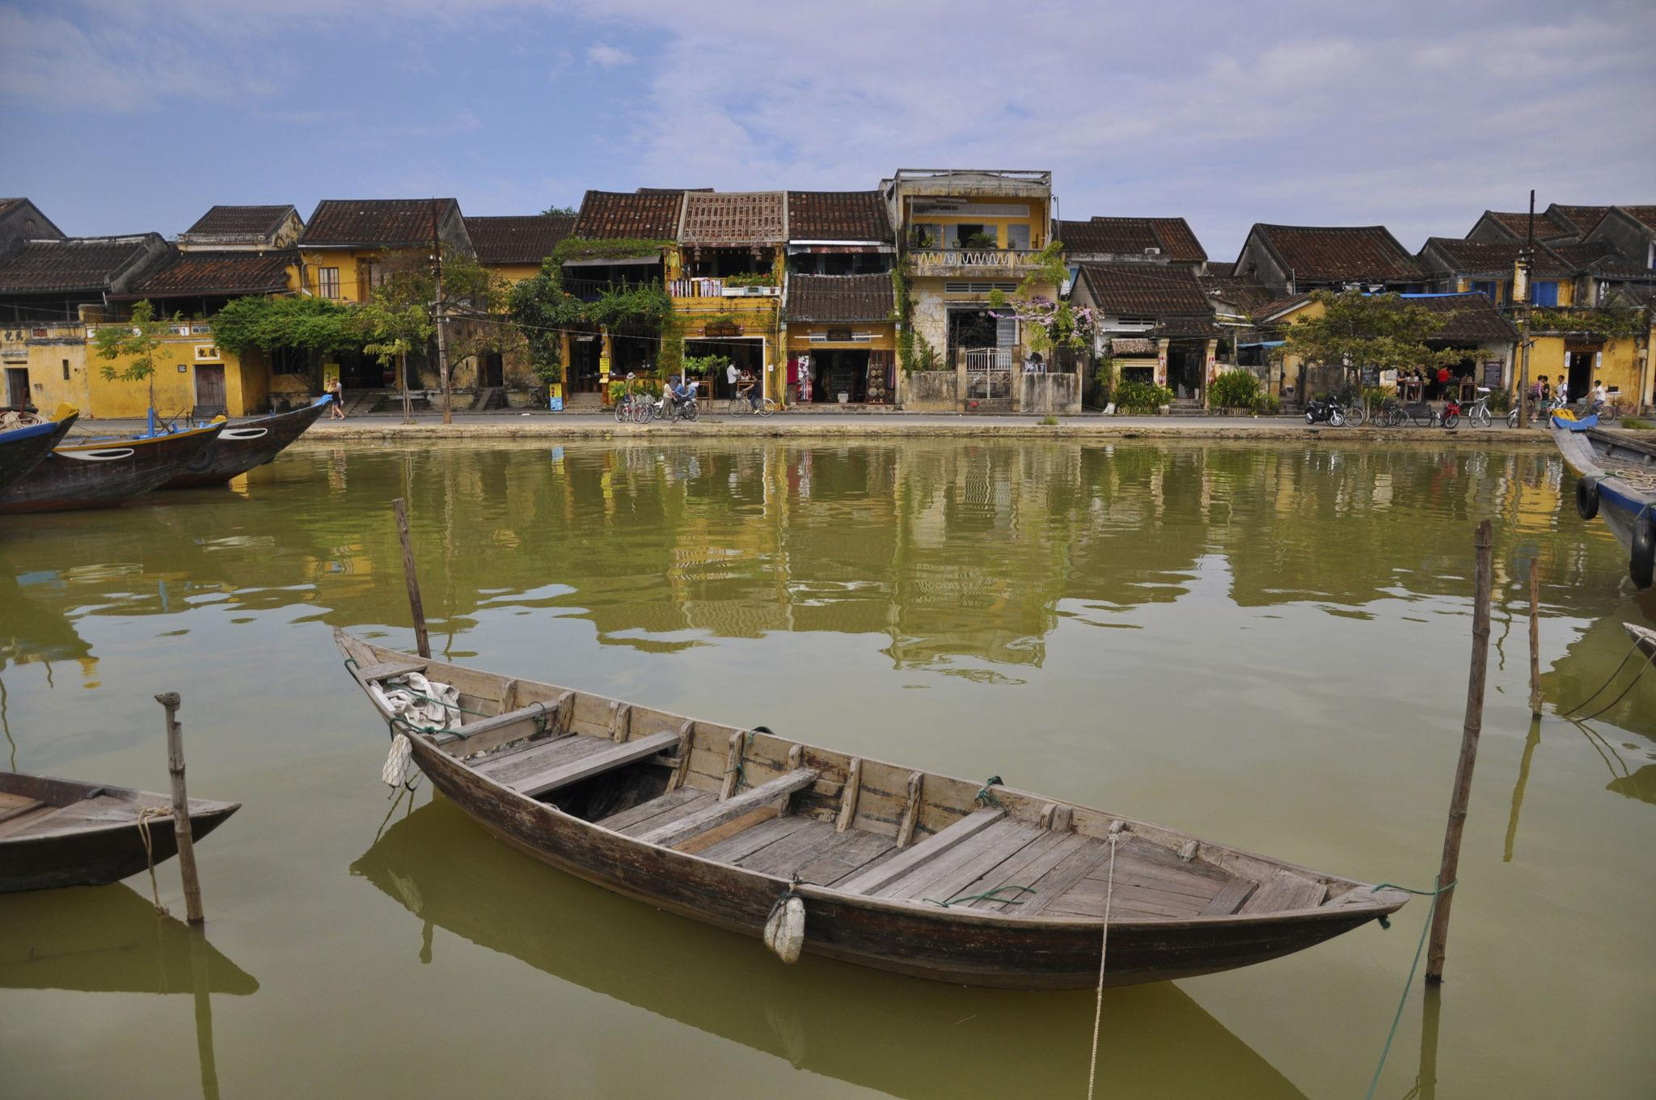
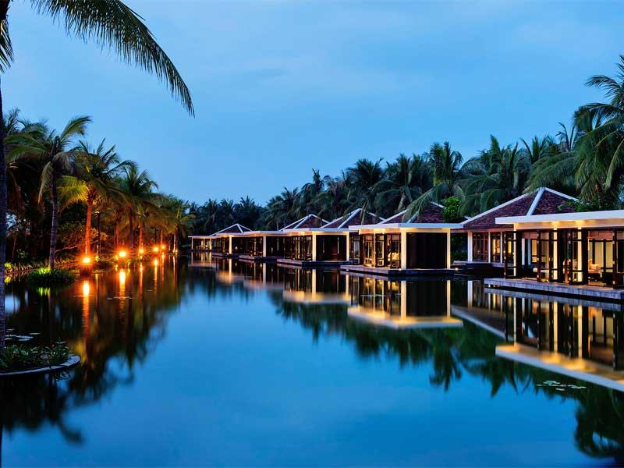
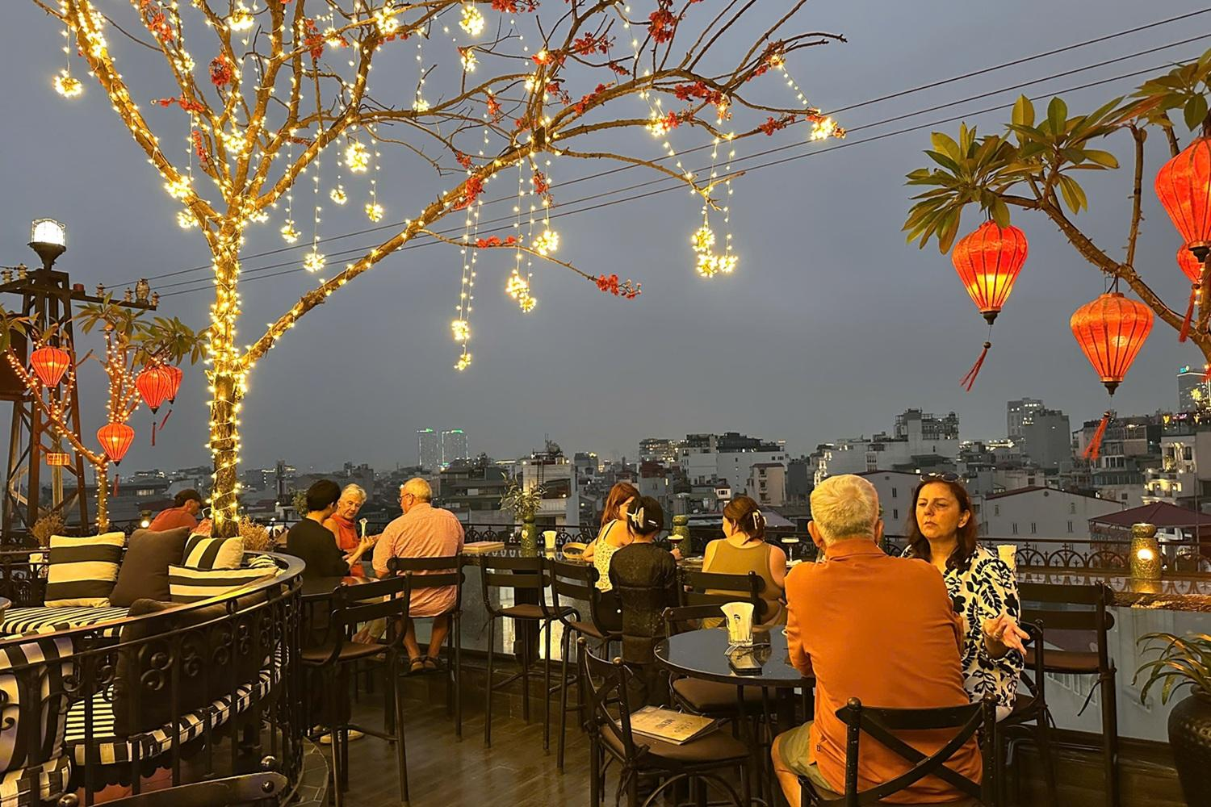

Vietnam Travel Tips
- Carry light cotton clothing
- Keep Vietnamese Dong currency
- Bargain politely at markets
- Try authentic local cafés
- Book cruises and flights early
- Respect local customs & temples

Why Choose INTRO TRAVELS INDIA for Vietnam?
With INTRO TRAVELS INDIA, you get:
- Customized Vietnam holiday packages
- Honeymoon & family tours
- Budget & luxury hotel options
- Visa assistance
- Airport transfers
- Guided sightseeing tours
- Indian meal options
- Cruise bookings
- Group departures & private tours
Vietnam is a destination where breathtaking nature, vibrant culture, delicious cuisine, rich history, and unforgettable adventures come together to create the perfect international holiday.

